

**Programming Method**

**Module Title**

**Air Pollution**

**DYNAMIC WEBSITES**

**Assignment Title**

**Winter 2020**

**Examination Cycle**

**PHYO PYAE MAUNG**

**Candidate Name**

**00188434**

**Candidate No**

**KMD Institute (Yangon)**

**Centre Name**

**16 October 2020**

**Submission Date:**

**Important Notes:**

* Please refer to the Assignment Presentation Requirements for advice on how to set out your

assignment. These can be found on the NCC Education *Campus*. Scroll down the left hand

side of the screen until you reach Personal Support. Click on this, and then on Policies and

Advice. You will find the Assignment Presentation Requirements under the Advice section.

* You must familiarise yourself with the NCC Education Academic Dishonesty and Plagiarism

Policy and ensure that you acknowledge all the sources which you use in your work. The

policy is available on *Campus*. Follow the instructions above, but click on Policies rather

than Advice.

* You must complete the **‘Statement and Confirmation of Own Work’**. The form is

available on the Policies section of *Campus*. Scroll down the left hand side until you reach

Personal Support. Click on this and then click on Policies and Advice.

* Please make a note of the recommended word count. You could lose marks if you write 10%

more or less than this.

* You must submit a paper copy and digital copy (on disk or similarly acceptable medium).

Media containing viruses, or media which cannot be run directly, will result in a fail grade

being awarded for this module.

* All electronic media will be checked for plagiarism. 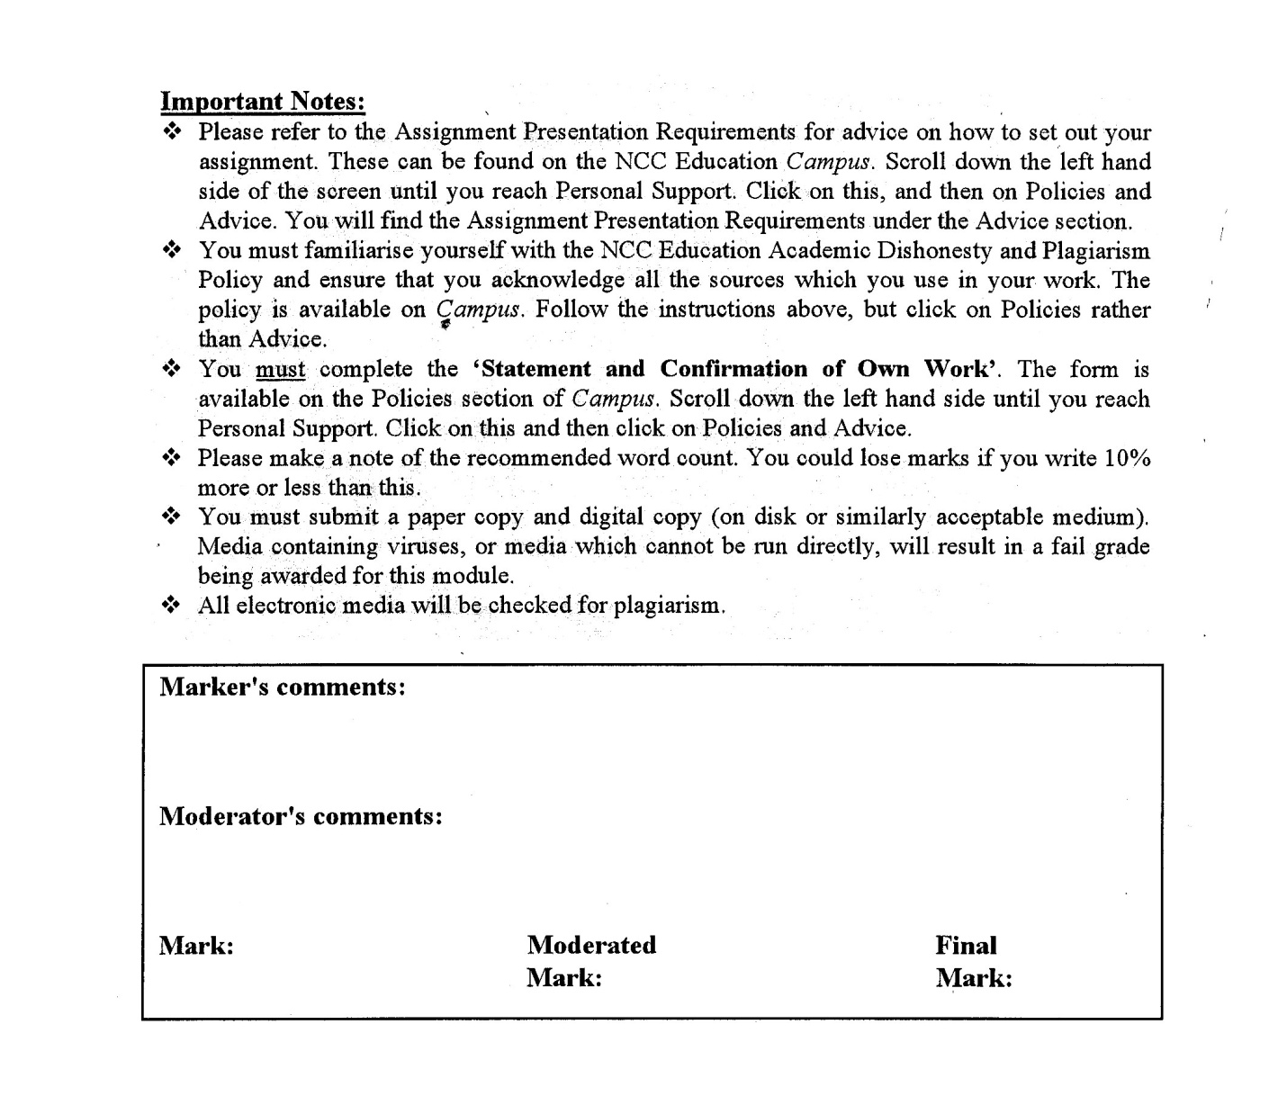



**Statement and Confirmation of Own Work**

**Programmed/Qualification Name: L5DC**

*All NCC Education assessed assignments submitted by students must have this statement as the cover page or it will not be accepted for marking. Please ensure that this statement is either firmly attached to the cover of the assignment or electronically inserted into the front of the assignment.*

**Student declaration**

I have read and understood NCC Education’s Policy on Academic Dishonesty and Plagiarism.

I can confirm the following details:

**Student ID/Registration number : 00188434**

**Name : PHYO PYAE MAUNG  
Centre Name : KMD Institute (Yangon)**

**Module Name : DYNAMIC WEBSITES  
Module Leader : YE PYAE PHYO  
Number of words : [7015] words**

I confirm that this is my own work and that I have not plagiarised any part of it. I have also noted the assessment criteria and pass mark for assignments.

**Due Date : 17 October 2020  
Student Signature : Phyo**

**Submitted Date : 16 October 2020**

# Introduction

According to the scenario, a website is needed to create that can provide information about air pollution, including data on air pollution levels now and in the past, in a country. Nowadays, air pollutions become a growing concern and it can affect both long-term and short-term for the health of people. The entrepreneurs of Air Pollution want to create a dynamic website which should include content that changes as the requirements of the user change. The website can offer an automatically loading background video, a fluid layout and responsive for reading and navigation on different devices. It also should include animation and interaction when accessing different social media buttons or navigation buttons. A database will be created to create an own personal account. Personal details of each user will be store in the database such as name, email, date of birth etc… Website must also include search engine optimization and include a responsive landing page that include a compelling headline, eye-catching images and media links to relevant pollution websites. The whole assignment can be used with these languages PHP,My SQL, JavaScript.

# Task -1

## Analysis

According to the scenario, in task 1 the design of home page or landing page will be created with compelling caption against a clean colorful backdrop, automatically loading background video eye-catching images scroll-triggered animations, responsive or fluid layout and animated social media buttons or navigation buttons.

## Assumptions

For the design, coding of CSS, JavaScript and html are used. All the animated buttons are coded with html and CSS. Navigations are decorated with colorful backdrop and eye catching images. All the images are arranged and placed. All the sizes are coded with CSS and html. Social Media buttons are placed in footer. The whole website is responsive in both PCs and mobiles. Background video is playing automatically and muted.

## Class Diagram



Class Diagram of Air Pollution

## Database Design

**Table name** - user

**Description** – To record user data

|  |  |  |  |
| --- | --- | --- | --- |
| **Column Name** | **Data type** | **Field size** | **Description** |
| UserID | **integer** | 11 | To define Primary key in user |
| FullName | **varchar** | 40 | To define the Fullname of User |
| Email | **varchar** | 40 | To define the Email of User |
| Password | **varchar** | 15 | To define the Password of User |
| DOB | **Date** | - | To define the date of birth of the User. |
| Address | **varchar** | 100 | To define the address of User |
| Postcode | **varchar** | 15 | To define the postcode of User |
| FreeKit | **varchar** | 100 | To define the gift for the User after he/she login |

Table name - staff

Description – To record the data of staff

|  |  |  |  |
| --- | --- | --- | --- |
| **Column Name** | **Data type** | **Field size** | **Description** |
| StaffID | **integer** | 11 | To define primary key in Staff |
| StaffName | **varchar** | 30 | To define the name of Staff |
| Email | **varchar** | 50 | To define the Staff’s email |
| Password | **varchar** | 50 | To define the password of the Staff |
| DOB | **Date** | - | To define the date of birth of the Staff |
| Phone | **varchar** | 60 | To define the Phone No. of the Staff |
| Address | **varchar** | 150 | To define the Address of Staff |

**Table name** – product_tbl

**Description** – To record the Product data

|  |  |  |  |
| --- | --- | --- | --- |
| **Column Name** | **Data type** | **Field size** | **Description** |
| ProductID | **integer** | 11 | To define primary key in Product |
| ProductImage | **varchar** | 255 | To define the Image of the Product |
| ProductName | **varchar** | 225 | To define the Name of Product |
| Type | **varchar** | 50 | To define the Type of the Product |
| Price | **int** | 11 | To define the Price of Product |
| Quantity | **Int** | 11 | To define the Quantity of Product |

**Table name** - history

**Description** – To record the data in history table

|  |  |  |  |
| --- | --- | --- | --- |
| **Column Name** | **Data type** | **Field size** | **Description** |
| HistoryrID | **integer** | 11 | To define primary key of History |
| PageName | **varchar** | 100 | To define name of Page |
| AccessTime | **Time** | - | To define time of Access |
| AccessDate | **Date** | - | To define date of Access |
| UserID | **integer** | 50 | To define primary key of User |

**Table name** – contact_us_tbl

**Description** – To record the data in contact_us_tbl table

|  |  |  |  |
| --- | --- | --- | --- |
| **Column Name** | **Data type** | **Field size** | **Description** |
| ContactUsID | integer | 11 | To define primary key of ContactUs |
| Questions | varchar | 200 | To define Questions that User asked. |
| Answer | varchar | 200 | To define Answers that Staff answered. |
| UserID | integer | 11 | To define primary key of User |
| QuestionDate | Date | - | To define the date of Question that User asked |
| QuestionTime | Time | - | To define the time of Question that User asked |

**Table name** - city

**Description** – To record the data of City

|  |  |  |  |
| --- | --- | --- | --- |
| **Column Name** | **Data type** | **Field size** | **Description** |
| CityrID | varchar | 100 | To define primary key in Cityreg |
| CityName | varchar | 50 | To define the name of City |
| CityImage | varchar | 255 | To define the photo of the City |
| PollutionRate | varchar | 100 | To define the air pollution rate of the city. |
| Description | varchar | 255 | To define the Description |

## Screen Design

Pages of this Air Pollution Website are Clean background with eye catching Image background



* Clean backdrop and can read every



* Eye-catching images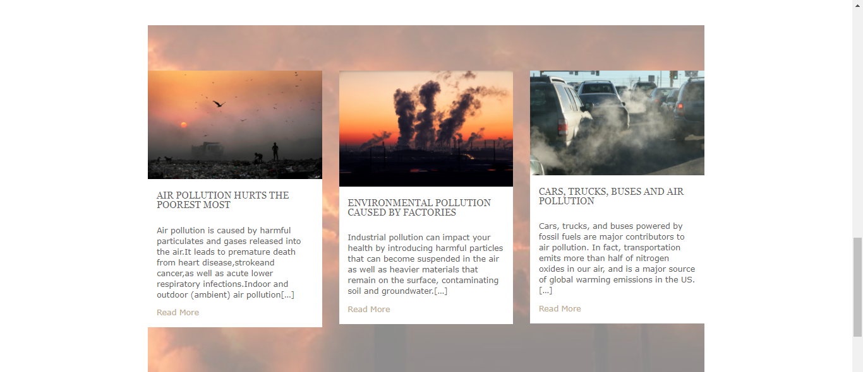 with some articles about Air Pollution
* 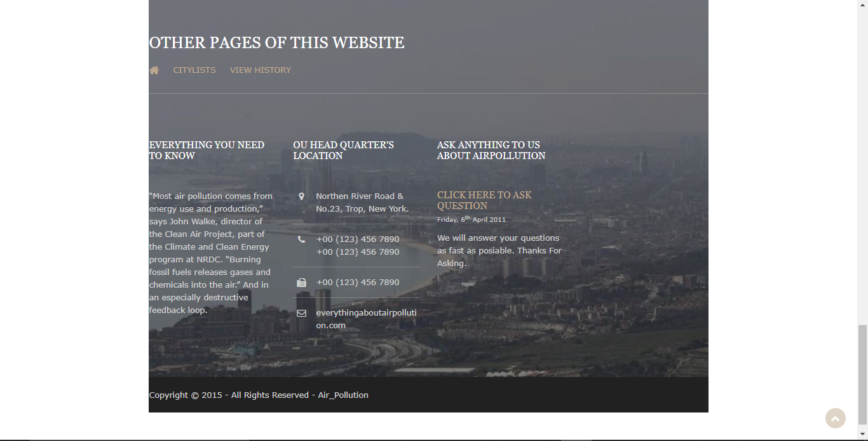Scroll-triggered animations and Others animations





* Automatic loading background video

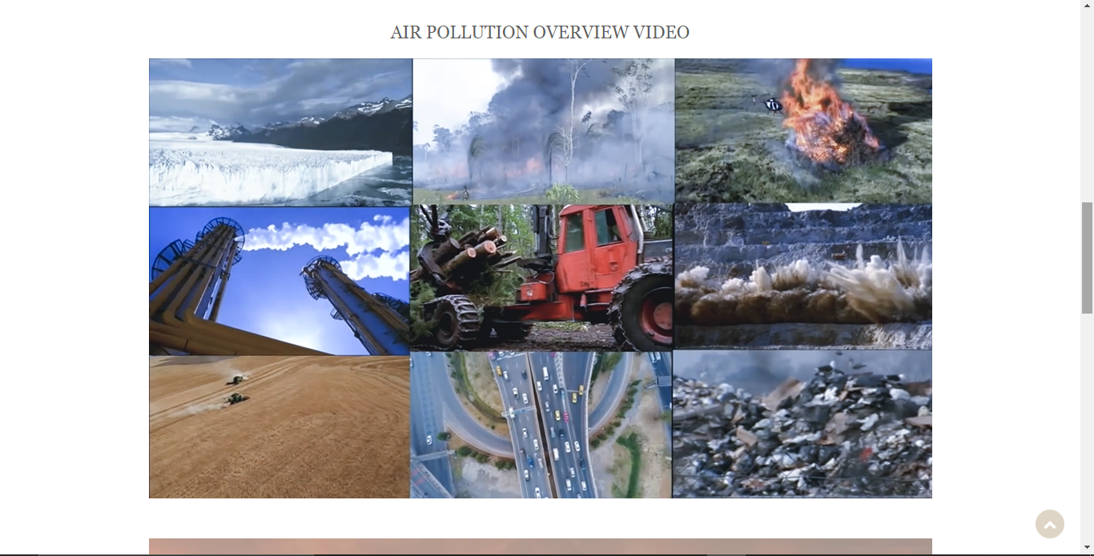

* Fluid layout

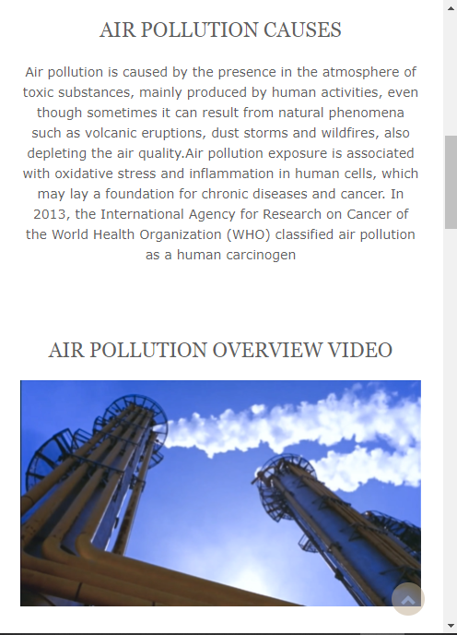

Interactive social media buttons or navigation buttons

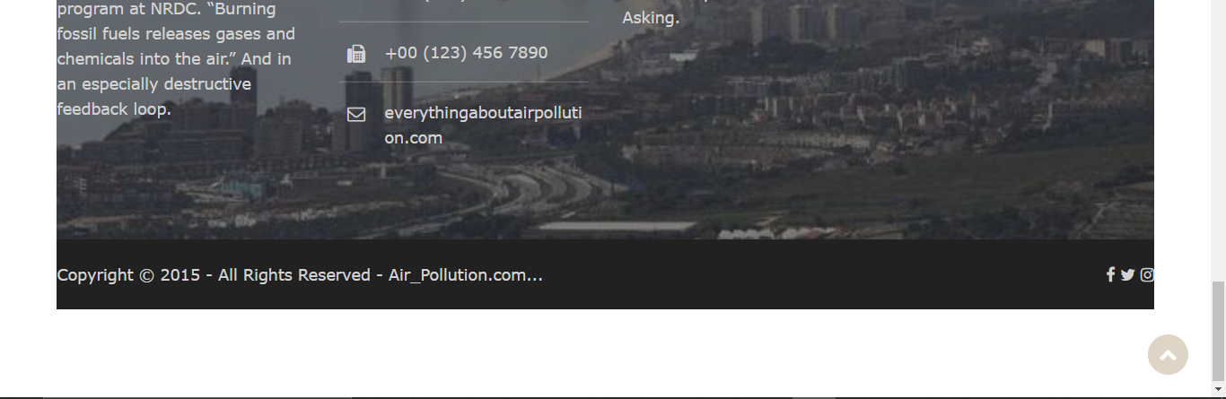

* Two media links to relevant pollution websites

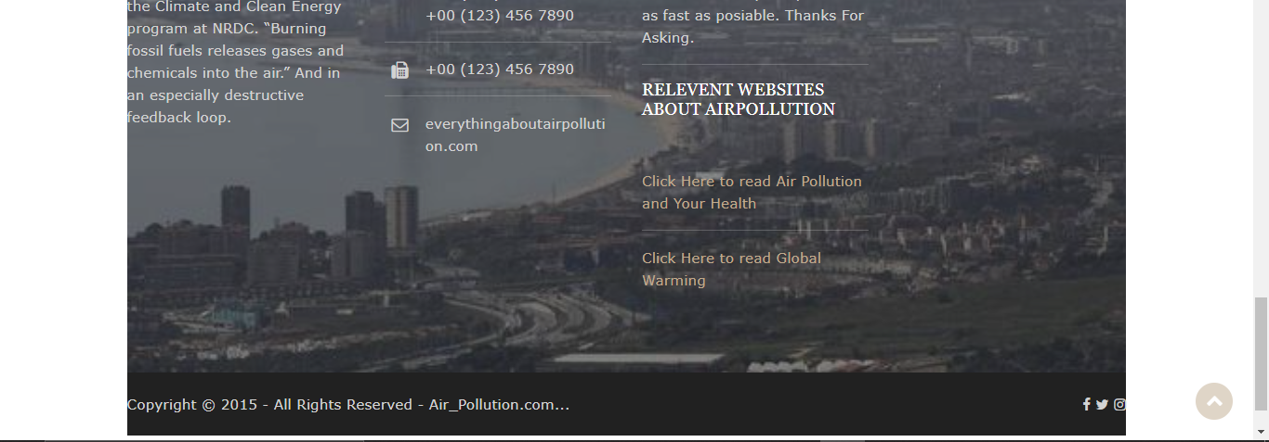

* One call to action button(sign-up) and (register)
* An offer of a free home pollution testing kit pop-up for signing up when the customer hovers over the sign-up action button

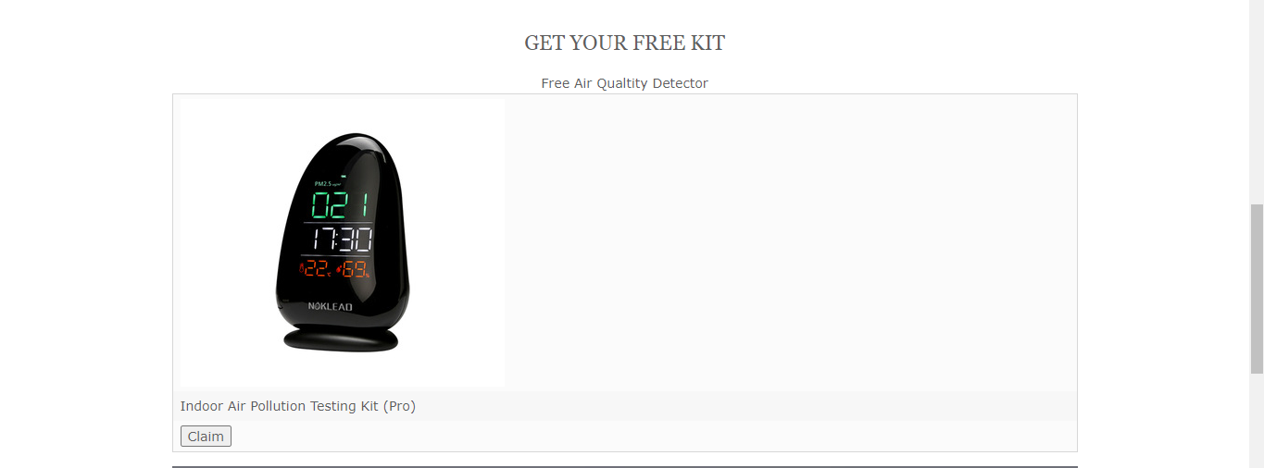

# Task – 2

## Analysis

According to the scenario, in task 2, there will be login and register forms for both User and Staff.

For register form, it consists of personal data such as User’s Name, Email, Password, DOB (Date of Birth), Address and Post Code. Also for the staff register form, it consists of Staff’s Name, Email, Password, DOB (Date of Birth), Address and Post Code. Both login forms for the Users and Staff are the same, it consists of User’s Email and Password for the User’s login form and Staff’s Email and Password for the Staff’s login form. And also both login forms cannot input incorrect Emails or Passwords more than 3 times. After that Users or Staff will have to wait “10 minutes” to Login in back to their Accounts.

## Assumptions

For creating the form, PHP and html languages will be used, so all the registration forms and login forms are coded with PHP and html and also Database is a part of this. In Database, tables will be created for keeping data when Users or Staff inserts their data. Sublime text is used for creating or coding the forms from above. PHP is used to work registrations and login and html is for the design the forms. And the password will be hashed with “md5” which is for 10 minutes Timer.

## Screen Design

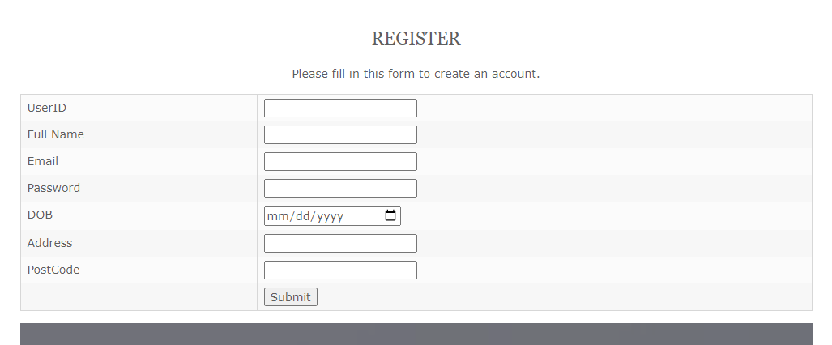

Fig: 1.0 User Register

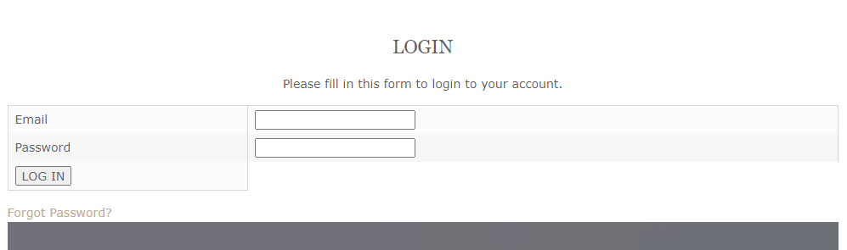

Fig: 1.1 User Login

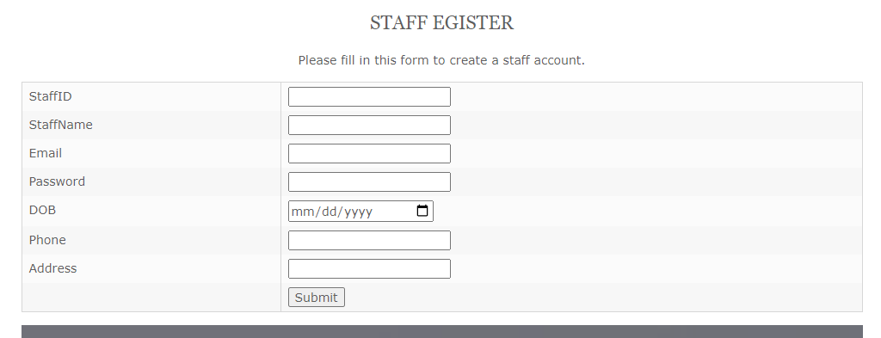

Fig: 1.3 Staff Register

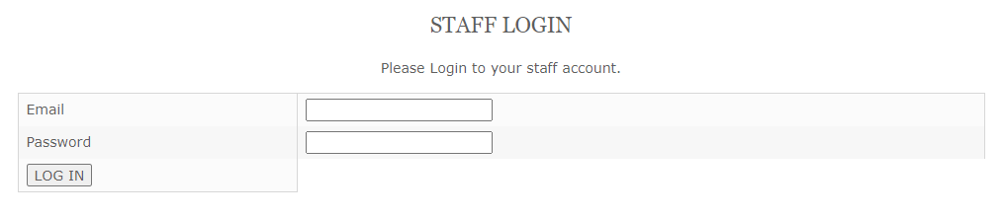

Fig: 1.4 Staff Login

## Coding

<?php

include ('Header.php');

$connect = mysqli_connect('localhost','root','','Air_Pullution');

if (isset($_POST['btnRegister']))

{

$UserID=$_POST['txtUserID'];

$FullName=$_POST['txtFullName'];

$Email=$_POST['txtEmail'];

$Password=$_POST['txtPassword'];

$DOB=$_POST['txtDOB'];

$Address=$_POST['txtAddress'];

$PostCode=$_POST['txtPostCode'];

$insert="INSERT INTO User VALUES ('$UserID','$FullName','$Email','$Password', '$DOB', '$Address', '$PostCode', 'Not Claim')";

$result = mysqli_query($connect,$insert);

if ($result)

{

echo "<script>alert('User Register Successful.');</script>";

}

else

{

echo mysqli_error($connect);

}

}

?>

<!DOCTYPE html>

<html>

<head>

<title></title>

</head>

<body>

<form action="user_reg.php" method="Post">

<h2 align="center">Register</h2>

<p align="center">Please fill in this form to create an account.</p>

<table>

<tr>

<td>UserID</td>

<td><input type="text" name="txtUserID" required></td>

</tr>

<tr>

<td>Full Name</td>

<td><input type="text" name="txtFullName" required></td>

</tr>

<tr>

<td>Email</td>

<td><input type="Email" name="txtEmail" required></td>

</tr>

<tr>

<td>Password</td>

<td><input type="Password" name="txtPassword" required></td>

</tr>

<tr>

<td>DOB</td>

<td><input type="Date" name="txtDOB" required></td>

</tr>

<tr>

<td>Address</td>

<td><input type="text" name="txtAddress" required></td>

</tr>

<tr>

<td>PostCode</td>

<td><input type="number" name="txtPostCode" required></td>

</tr>

<tr>

<td></td>

<td><input type="submit" name="btnRegister" placeholder="Register"></td>

</tr>

</table>

</form>

</body>

</html>

<?php include ('Footer.php');

?>

Coding of User Register

<?php

include ('Header.php');

$connect = mysqli_connect('localhost','root','','Air_Pullution');

if (isset($_POST['btnRegister']))

{

$UserID=$_POST['txtUserID'];

$FullName=$_POST['txtFullName'];

$Email=$_POST['txtEmail'];

$Password=md5($_POST['txtPassword']);

$DOB=$_POST['txtDOB'];

$Address=$_POST['txtAddress'];

$PostCode=$_POST['txtPostCode'];

$insert="INSERT INTO User VALUES ('$UserID','$FullName','$Email','$Password', '$DOB', '$Address', '$PostCode', 'Not Claim')";

$result = mysqli_query($connect,$insert);

if ($result)

{

echo "<script>alert('User Register Successful.');</script>";

}

else

{

echo mysqli_error($connect);

}

}

?>

<!DOCTYPE html>

<html>

<head>

<title></title>

</head>

<body>

<form action="user_reg.php" method="Post">

<h2 align="center">Register</h2>

<p align="center">Please fill in this form to create an account.</p>

<table>

<tr>

<td>UserID</td>

<td><input type="text" name="txtUserID" required></td>

</tr>

<tr>

<td>Full Name</td>

<td><input type="text" name="txtFullName" required></td>

</tr>

<tr>

<td>Email</td>

<td><input type="Email" name="txtEmail" required></td>

</tr>

<tr>

<td>Password</td>

<td><input type="Password" name="txtPassword" required></td>

</tr>

<tr>

<td>DOB</td>

<td><input type="Date" name="txtDOB" required></td>

</tr>

<tr>

<td>Address</td>

<td><input type="text" name="txtAddress" required></td>

</tr>

<tr>

<td>PostCode</td>

<td><input type="number" name="txtPostCode" required></td>

</tr>

<tr>

<td></td>

<td><input type="submit" name="btnRegister" placeholder="Register"></td>

</tr>

</table>

</form>

</body>

</html>

<?php include ('Footer.php');

?>

Coding of User Login

<?php

include('Header.php');

$connection=mysqli_connect('localhost','root','','Air_Pullution');

if (isset($_SESSION['LoginTime'])) {

$T=time();

$E=$_SESSION['LoginTime'];

if ($T>=$E) {

unset($_SESSION['Fail']);

}

}

if (isset($_POST['Fail'])){

echo "<script>window.location='timer.php';</script>";

}

if (isset($_POST['btnLogin'])){

$Email=$_POST['txtEmail'];

$Password=md5($_POST['txtPassword']);

echo $select="SELECT * FROM user

WHERE Email='$Email'

AND Password='$Password'";

$ret=mysqli_query($connection,$select);

$count=mysqli_num_rows($ret);

if ($count>0) {

$arr=mysqli_fetch_array($ret);

$_SESSION['UserID']=$arr['UserID'];

echo "<script>alert('Login Successful.')</script>";

echo "<script>window.location='Home.php';</script>";

}

else{

if (isset($_SESSION['LoginError']))

{

$countError=$_SESSION['LoginError'];

if ($countError==1)

{

$_SESSION['LoginError']=2;

echo "<script>window.alert('Login failed! Please try again! Error Attempt 2')</script>";

}

if ($countError==2)

{

$_SESSION['Fail']='True';

$_SESSION['LoginTime']=time()+(60+10);

echo "<script>window.alert('Login failed! Error Attempt 3! Account is Locked for 10mins!!')</script>";

echo "<script>window.location='timer.php';</script>";

}

}

else

{

$_SESSION['LoginError']=1;

echo "<script>window.alert('Login failed! Please try again! Error Attempt 1')</script>";

}

}

}

if (isset($_SESSION['UserID'])) {

$UserID=$_SESSION['UserID'];

$PageName="Login.php";

$AccessDate=date('Y-m-d');

date_default_timezone_set('Asia/Yangon');

$AccessTime=date('h:i:sa');

$Insert="INSERT INTO history(PageName,AccessDate,AccessTime,UserID) VALUES ('$PageName','$AccessDate','$AccessTime','$UserID')";

$ret1=mysqli_query($connection,$Insert);

}

?>

<!DOCTYPE html>

<html>

<head>

<title></title>

</head>

<body>

<h2 align="center">Login</h2>

<p align="center">Please fill in this form to login to your account.</p>

<!-- Login Form -->

<form action="login.php" method="POST">

<table>

<tr>

<td>Email</td>

<td><input type="email" name="txtEmail" required></td>

</tr>

<tr>

<td>Password</td>

<td><input type="password" name="txtPassword" required></td>

</tr>

<tr>

<td><input type="submit" name="btnLogin" value="LOG IN"></td>

</tr>

</table>

</form>

</div>

</div>

</body>

</html>

<?php include ('Footer.php');?>

Coding of User Update

<?php

include('Header.php');

$connection = mysqli_connect('localhost','root','','Air_Pullution');

if (!isset($_SESSION['UserID'])){

echo "<script>alert('Please Login First.')</script>";

echo "<script>window.location='login.php';</script>";

}

else{

$UID=$_SESSION['UserID'];

$select="SELECT * FROM user

WHERE UserID='$UID'";

$result=mysqli_query($connection,$select);

$arr=mysqli_fetch_array($result);

}

if (isset($_POST['btnUpdate'])) {

$Name=$_POST['txtName'];

$Email=$_POST['txtEmail'];

$OldPassword=($_POST['txtOldPassword']);

$NewPassword=($_POST['txtNewPassword']);

$ConfirmPassword=($_POST['txtConfirmPassword']);

if ($NewPassword==$ConfirmPassword) {

$UID=$_SESSION['UserID'];

$select2="SELECT * FROM user WHERE UserID='$UID'";

$result3=mysqli_query($connection,$select2);

$arr2=mysqli_fetch_array($result3);

if ($OldPassword==$arr['Password']) {

$update2="UPDATE user SET

Password='$NewPassword',

Name='$Name',

Email='$Email'

Where UserID='$UID'";

$ret2=mysqli_query($connection,$update2);

if ($ret2) {

unset($_SESSION['UserID']);

echo "<script>alert('Change Password Successful.');</script>";

echo "<script>window.location='login.php';</script>";

}

}

else{

echo "<script>alert('Your Password is not correct.');</script>";

}

}

else{

echo "<script>alert('New Password and Confirm Password does not match.');</script>";

}

}

if (isset($_SESSION['UserID'])) {

$UserID=$_SESSION['UserID'];

$PageName="UserUpdate.php";

$AccessDate=date('Y-m-d');

date_default_timezone_set('Asia/Rangoon');

$AccessTime=date('h:i:sa');

$Insert="INSERT INTO history (PageName,AccessTime,AccessDate,UserID) VALUES ('$PageName','$AccessTime','$AccessDate','$UserID')";

$result2=mysqli_query($connection,$Insert);

}

?>

<!DOCTYPE html>

<html>

<head>

<title></title>

</head>

<link rel="stylesheet" type="text/css" href="box.css">

<body>

<div align="center">

<form action="user_update.php" method="POST" enctype="multipart/form-data" >

<table align="center">

<div class="about" id="about">

<div class="wrap">

<div class="head">

<span> </span>

<h3>User Update</h3>

<p align="center">Please fill this to update your account.</p>

</div>

<td><b>Name</b></td>

<td><input type="text" class="input-box" name="txtName" value="<?php echo $arr['FullName']; ?>"></td>

</tr>

<tr>

<td><b>Email</b></td>

<td><input type="text" class="input-box" name="txtEmail" value="<?php echo $arr['Email']; ?>"></td>

</tr>

<tr>

<td><b>Old Password</b></td>

<td><input type="text" class="input-box" name="txtOldPassword" placeholder="Your Old Password" required></td>

</tr>

<tr>

<td><b>New Password</b></td>

<td><input type="text" class="input-box" name="txtNewPassword" placeholder="Your New Password" required></td>

</tr>

<tr>

<td><b>Confirm Password</b></td>

<td><input type="text" class="input-box" name="txtConfirmPassword" placeholder="Your Confirm Password" required></td>

</tr>

<tr>

<td></td>

<td>

<input type="submit" class="input-box" name="btnUpdate" value="Update">

</td>

</tr><br>

</div><br>

</table><br>

</form>

</div>

</body>

</html>

<?php

include('footer.php')

?>

Coding of Staff Register

<?php

include ('Header2.php');

$connect = mysqli_connect('localhost','root','','Air_Pullution');

if (isset($_POST['btnRegister']))

{

$StaffID=$_POST['txtStaffID'];

$StaffName=$_POST['txtStaffName'];

$Email=$_POST['txtEmail'];

$Password=$_POST['txtPassword'];

$DOB=$_POST['txtDOB'];

$Phone=$_POST['txtPhone'];

$Address=$_POST['txtAddress'];

$insert="INSERT INTO Staff VALUES ('$StaffID','$StaffName','$Email','$Password', '$DOB', '$Phone', '$Address')";

$result = mysqli_query($connect,$insert);

if ($result)

{

echo "<script>alert('Staff Register Successful.');</script>";

}

else

{

echo mysqli_error($connect);

}

}

?>

<!DOCTYPE html>

<html>

<head>

<title></title>

</head>

<body>

<form action="staff_reg.php" method="Post">

<h2 align="center">Staff Register</h2>

<p align="center">Please fill in this form to create a staff account.</p>

<table>

<tr>

<td>StaffID</td>

<td><input type="text" name="txtStaffID" required></td>

</tr>

<tr>

<td>StaffName</td>

<td><input type="text" name="txtStaffName" required></td>

</tr>

<tr>

<td>Email</td>

<td><input type="Email" name="txtEmail" required></td>

</tr>

<tr>

<td>Password</td>

<td><input type="Password" name="txtPassword" required></td>

</tr>

<tr>

<td>DOB</td>

<td><input type="Date" name="txtDOB" required></td>

</tr>

<tr>

<td>Phone</td>

<td><input type="text" name="txtPhone" required></td>

</tr>

<tr>

<td>Address</td>

<td><input type="text" name="txtAddress" required></td>

</tr>

<tr>

<td></td>

<td><input type="submit" name="btnRegister" placeholder="Register"></td>

</tr>

</table>

</form>

</body>

</html>

<?php include ('Footer.php');?>

Coding of Staff Login

<?php session_start(); ?>

<!DOCTYPE html>

<html>

<head>

<style>

p{

text-align: center;

font-size : 30px;

margin-top : 0px;

}

</style>

<title></title>

</head>

<body>

<p id="Timer"></p>

<script>

var month = new Date().getMonth()+1;

var day = new Date().getDate();

var year = new Date().getFullYear();

var hour = new Date().getHours();

var minute = new Date().getMinutes()+10;

var second = new Date().getSeconds();

var time= hour+":"+minute+":"+second;

var ResetTime = new Date(month+" "+day+","+year+" "+time).getTime();

var x = setInterval(function()

{

var now = new Date().getTime();

var distance = ResetTime - now;

var hour = Math.floor((distance % (1000 * 60 * 60 * 60)) / (1000 * 60 * 60));

var minutes = Math.floor((distance % (1000 * 60 * 60)) / (1000 * 60));

var seconds = Math.floor((distance % (1000* 60)) / 1000);

document.getElementById('Timer').innerHTML = "<h1>Please Try Again In</h1>" + minutes+"m"+seconds+"s"+"<h1> To Login Again.</h1>";

if (distance<0) {

clearInterval(x);

location='stafflogin.php';

document.getElementById('Timer').innerHTML="<?php session_destroy();?>";

}

}, 1000);

</script>

</body>

</html>

Coding of Staff Timer

## Testing of User Register

**Test Case 1**

|  |  |
| --- | --- |
| Test objective | Check the work of register |
| Test Data | Name=”Mg Mg”, Email=[maungmaung@gmail.com](mailto:maungmaung@gmail.com), Password=”maungmaung”, Date of Birth=”3/10/1997”, Postalcode=”Yangon”, PostCode=”002” |
| Test Procedure | Fill all the data and Click Register button. |
| Expected Result | Message will show. |
| Actual Result | Fig: 1.4 |

Before Testing

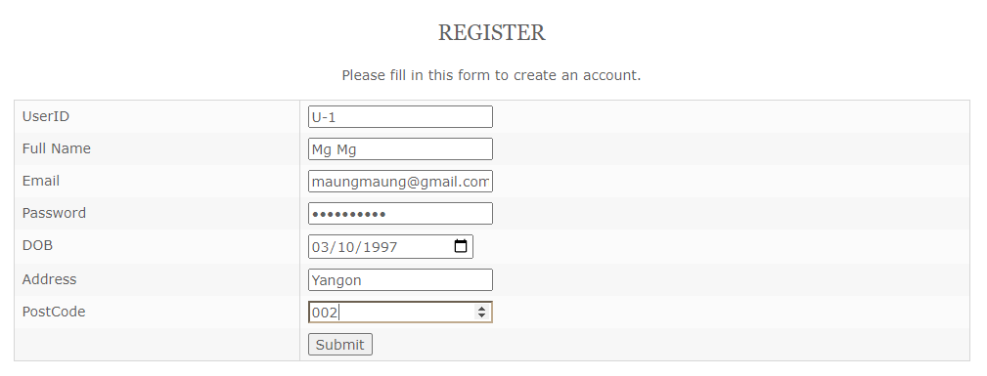

Fig - 1.3

After Testing

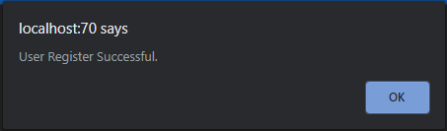

Fig - 1.4

**Test Case 2**

|  |  |
| --- | --- |
| Test objective | User hashes the password and the hashing password is saved in database. |
| Test Data | Name=”Mg Mg”, Email=[maungmaung@gmail.com](mailto:maungmaung@gmail.com), Password=”maungmaung”, Date of Birth=”3/10/1997”, Postalcode=”Yangon”, PostCode=”002” |
| Test Procedure | Fill all the data and Click Register button. |
| Expected Result | Hashing password will saved in database |
| Actual Result | Fig: 1.6 |

Before Testing



Fig-1.5

After Testing



Fig-1.6

## Testing of User Login

**Test Case 1**

|  |  |
| --- | --- |
| Test objective | Check the User Log in form. |
| Test Data | Email= [maungmaung@gmail.com](mailto:maungmaung@gmail.com) , Password=”maungmaung” |
| Test Procedure | Fill the data and Click the Login Button |
| Expected Result | Message box will show. |
| Actual Result | Fig: 1.8 |

Before Testing

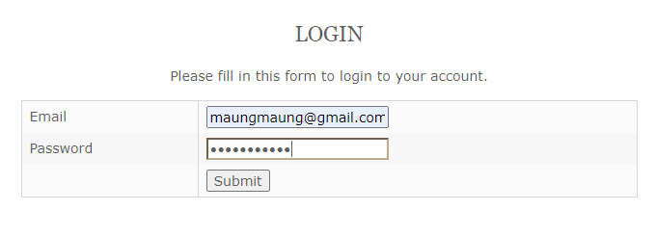

Fig-1.7

After Testing

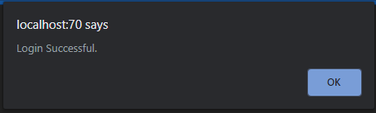

Fig-1.8

**Test Case 2**

|  |  |
| --- | --- |
| Test objective | If user fill wrong email or password, the error message will show to the user.(Attempt 1) |
| Test Data | Email = [maungmaung@gmail.com](mailto:maungmaung@gmail.com) , Password=”123456” |
| Test Procedure | Enter the Wrong password and then Click Login button. |
| Expected Result | Show an error message box |
| Actual Result | Fig: 1.10 |

Before Testing

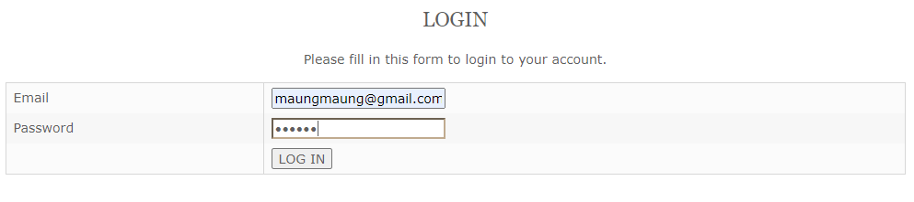

Fig-1.9

After Testing

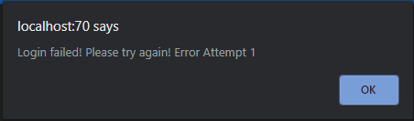

Fig-1.10

**Test Case 3**

|  |  |
| --- | --- |
| Test objective | If user check wrong email and password, the error message will show to the user.(Attempt 2) |
| Test Data | Email= [tuntun@gmail.com](mailto:tuntun@gmail.com), Password=”123456” |
| Test Procedure | Enter the wrong email and then Click the Login Button. |
| Expected Result | Show an error message box |
| Actual Result | Fig: 1.12 |

Before Testing

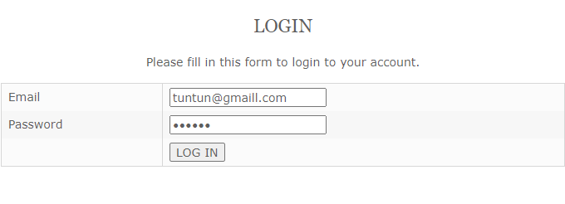

Fig:1.11

After Testing

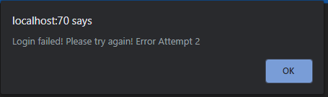

Fig:1.12

**Test Case 4**

|  |  |
| --- | --- |
| Test objective | Checking that user can’t login more than three times, after that user has to wait 10 minutes. |
| Test Data | Email= [tuntun@gmail.com](mailto:tuntun@gmail.com), Password=”maungmaung” |
| Test Procedure | Enter wrong email and password and then Click the Login button. |
| Expected Result | Show an error message box |
| Actual Result | Fig: 1.14, 1.15 |

Before Testing

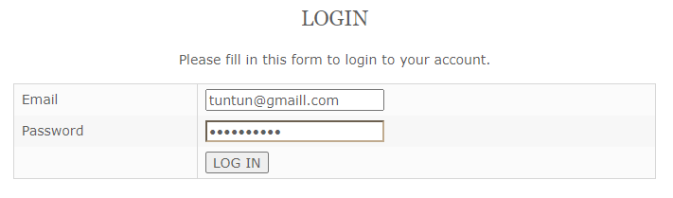

Fig-1.13

After Testing

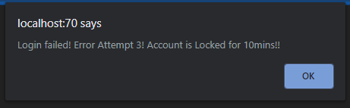

Fig-1.14

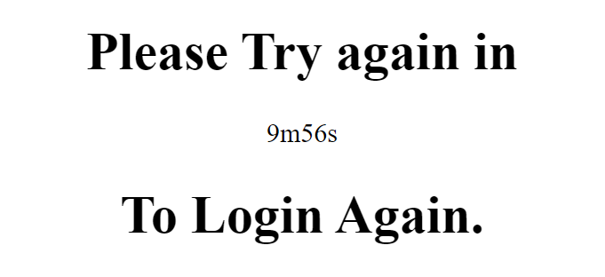

Fig-1.15

## Testing of User Update

**Test Case 1**

|  |  |
| --- | --- |
| Test objective | Check the User update. |
| Test Data | Old Password=”maungmaung”, New Password=”mgmg” Confirm Password=”mgmg” |
| Test Procedure | Enter all the data and Click the Update button. |
| Expected Result | Show a message box |
| Actual Result | Fig: 1.16 |

Before Testing

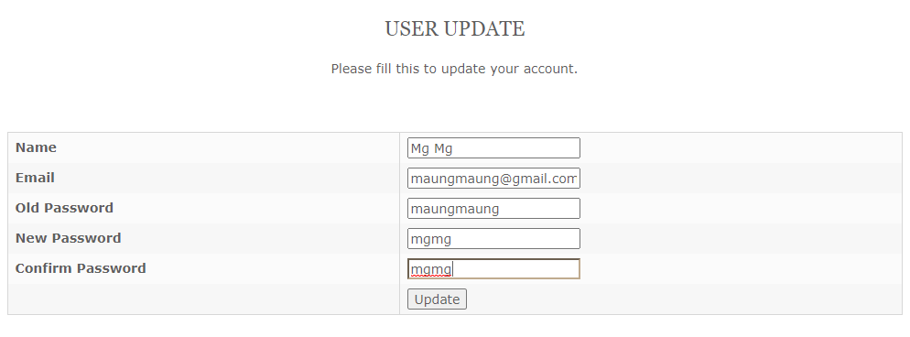

Fig-1.15

After Testing

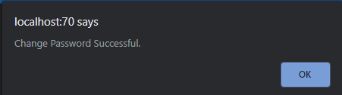

Fig-1.16

**Test Case 2**

|  |  |
| --- | --- |
| Test objective | When wrong password was entered then the error message will show user. |
| Test Data | Old Password=”mgmg”, New Password=”1234” Confirm Password=”1234” |
| Test Procedure | Enter all the data and Click the Update button. |
| Expected Result | Show a message box |
| Actual Result | Fig: 1.18 |

Before Testing

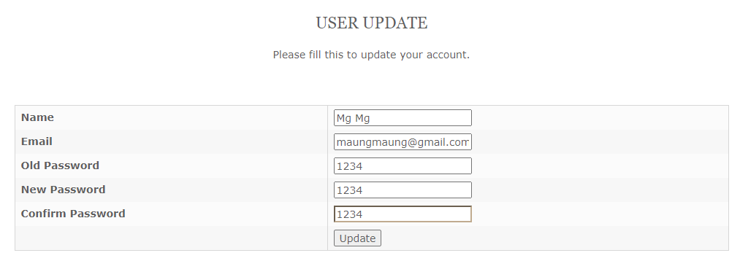

Fig-1.17

After Testing

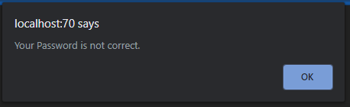

Fig:1.18

## Testing of Staff Register

**Test Case 1**

|  |  |
| --- | --- |
| Test objective | To check the Staff Registration |
| Test Data | Staff Name=”Kyaw Kyaw”, Staff Age=”28”, Email=[kyawkyaw@gmail.com](mailto:kyawkyaw@gmail.com), Password=”322003”, Address=”Yangon” |
| Test Procedure | Enter all data and Click the Register button |
| Expected Result | Show a message box |
| Actual Result | Fig: 1.4 |

Before Testing

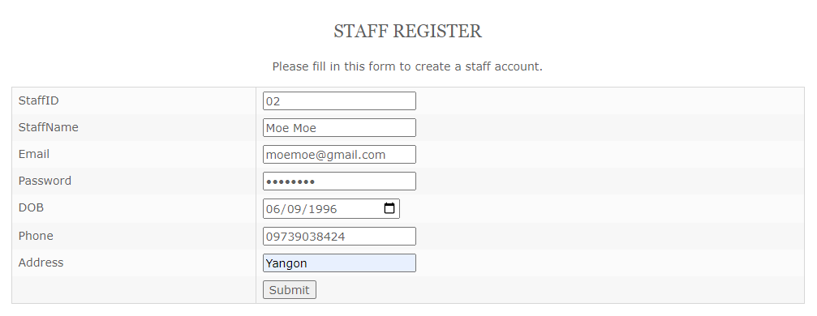

Fig-1.3

After Testing

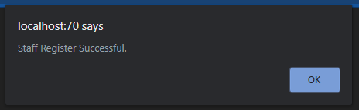

Fig-1.4

## Testing of Staff Login

**Test Case 1**

|  |  |
| --- | --- |
| Test objective | Check the Staff Login |
| Test Data | Email=[tuntun@gmail.com](mailto:tuntun@gmail.com), Password=”12345678” |
| Test Procedure | Enter all data and Click the Login button |
| Expected Result | Show a message box |
| Actual Result | Fig: 1.8 |

Before Testing

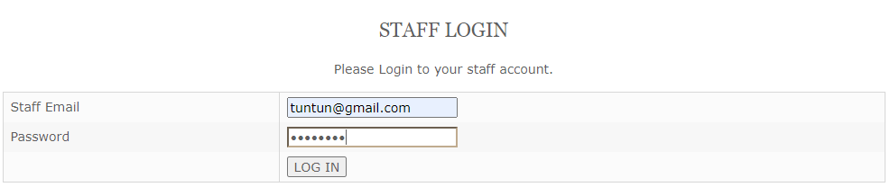

Fig-1.7

After Testing

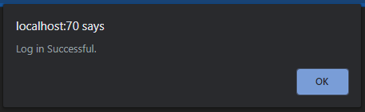

Fig-1.8

**Test Case 2**

|  |  |
| --- | --- |
| Test objective | When staff input wrong email and password, the error message will show to the staff. |
| Test Data | Email=[tuntun@gmail.com](mailto:tuntun@gmail.com), Password=”12345” |
| Test Procedure | Enter wrong email and password and then Click the Login Button |
| Expected Result | Show an error message box |
| Actual Result | Fig: 1.10 |

Before Testing

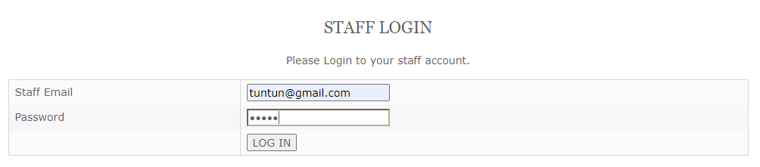

Fig-1.9

After Testing

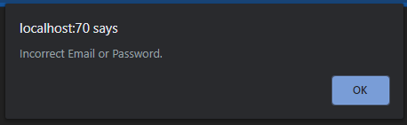

Fig-1.10

**Test Case 3**

|  |  |
| --- | --- |
| Test objective | If staff input wrong email and password again, the error message will show to the staff again. |
| Test Data | Email=[kyawkyaw2@gmail.com](mailto:kyawkyaw2@gmail.com), Password=”000000” |
| Test Procedure | Enter wrong email and password and then Click the Login button |
| Expected Result | Show an error message box |
| Actual Result | Fig: 1.12 |

Before Testing

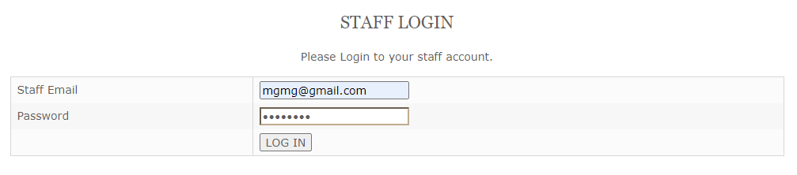

Fig-1.11

After Testing



Fig-1.12

**Test Case 4**

|  |  |
| --- | --- |
| Test objective | To check that staff cannot login three times, then the staff has to wait 10 minutes. |
| Test Data | Email=[kyawkyaw@gmail.com](mailto:kyawkyaw@gmail.com), Password=”000000” |
| Test Procedure | Enter wrong email and password and then Click the Login Button |
| Expected Result | Show an error message box |
| Actual Result | Fig: 1.14, 1.15 |

Before Testing

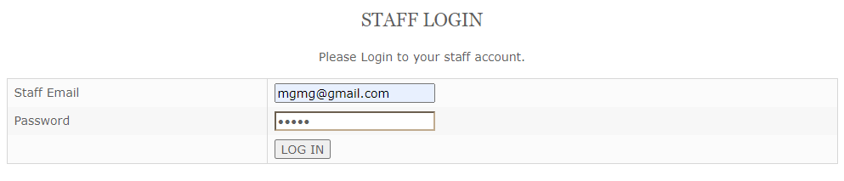

Fig-1.13

After Testing

Fig:1.14

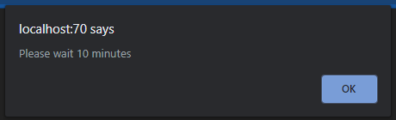



Fig-1.15

# Task-3

## Analysis

In task 3, at first you User have to Login to his or her account to ask questions. User can ask questions about the Air Pollution or the about this website from Contact Us form and User can check back their questions and answers that are answered from the website.

## Assumptions

To keep the questions that Users asked, Contact Us table is created in the database. When a User asked a question, the question and User Name will direct save to the Contact Us table. For that working process PHP, CSS, MySQL are used to create forms and tables in database. Real time system is also included in the process that will know exactly date and time when user submitted the question. FAQ will show the answers and question that the user asked. In a staff view of viewquestion page there is answer link to where staff can be answered the question that User submitted.

## Screen Design

**Contact Us**

## 

Fig-2.1

**FAQ**



Fig-2.2

**View Question**

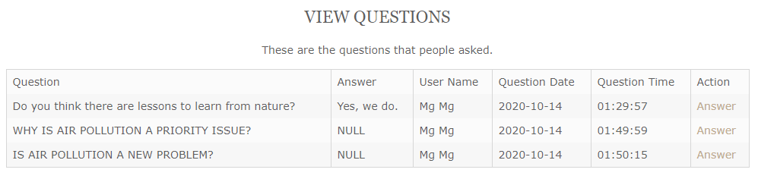

Fig-2.3

**Answers**

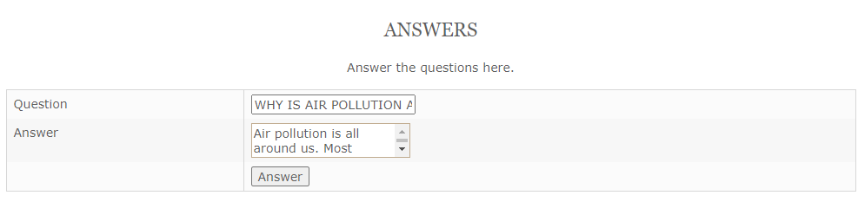

Fig-2.4

## Coding

<?php

include ('Header.php');

$connection=mysqli_connect("localhost","root","","Air_Pullution");

if (isset($_SESSION['UserID'])) {

$UserID=$_SESSION['UserID'];

$query="SELECT * FROM User WHERE UserID = '$UserID'";

$result= mysqli_query($connection,$query);

$arr = mysqli_fetch_array($result);

}

else

{

echo "<script>alert('Please Login First.');</script>";

echo "<script>window.location='login.php';</script>";

}

if (isset($_POST['btncontactus'])) {

$UserID= $_POST['txtuserID'];

$Question= $_POST['txtquestion'];

date_default_timezone_set('Asia/Rangoon');

$QuestionDate=date('Y-m-d');

$QuestionTime=date('h:i:sa');

$insert="INSERT into contact_us_tbl (Questions,Answer,UserID,QuestionDate,QuestionTime) VALUES ('$Question','NULL','$UserID','$QuestionDate','$QuestionTime')";

$ret = mysqli_query($connection,$insert);

if ($ret) {

echo"<script>alert('Question ask successful');</script>";

}

else{

echo mysqli_error($connection);

}

}

if (isset($_SESSION['UserID'])) {

$UserID=$_SESSION['UserID'];

$PgName="ContactUs.php";

$AccessDate=date('Y-m-d');

date_default_timezone_set('Asia/Yangon');

$AccessTime=date('h:i:sa');

$Insert="INSERT INTO history (PageName,AccessDate,AccessTime,UserID) VALUES ('$PgName','$AccessDate','$AccessTime','$UserID')";

$ret1=mysqli_query($connection,$Insert);

}

?>

<!DOCTYPE html>

<html>

<head>

<title></title>

</head>

<body>

<form action = "ContactUs.php" method = "POST">

<h2 align="center">Contact Us</h2>

<p align="center">Please ask here, we will respond your answer as soon as posible.</p>

<input type="hidden" name="txtuserID" value="<?php echo $arr ['UserID'] ?>">

<table>

<tr>

<td>Questions</td>

<td><input type="text" name="txtquestion" required ></td>

</tr>

<tr>

<td>User Name</td>

<td><input type="text" name="txtusername" value = "<?php echo $arr ['FullName'] ?>" readonly></td>

</tr>

<tr>

<td></td>

<td><input type="submit" name="btncontactus" value = "Ask"></td>

</tr>

</table>

</form>

</body>

</html>

<?php include ('Footer.php');?> <?php

include ('Header.php');

$connection=mysqli_connect("localhost","root","","Air_Pullution");

if (isset($_SESSION['UserID'])) {

$UserID=$_SESSION['UserID'];

$query="SELECT * FROM User WHERE UserID = '$UserID'";

$result= mysqli_query($connection,$query);

$arr = mysqli_fetch_array($result);

}

else

{

echo "<script>alert('Please Login First.');</script>";

echo "<script>window.location='login.php';</script>";

}

if (isset($_POST['btncontactus'])) {

$UserID= $_POST['txtuserID'];

$Question= $_POST['txtquestion'];

date_default_timezone_set('Asia/Rangoon');

$QuestionDate=date('Y-m-d');

$QuestionTime=date('h:i:sa');

$insert="INSERT into contact_us_tbl (Questions,Answer,UserID,QuestionDate,QuestionTime) VALUES ('$Question','NULL','$UserID','$QuestionDate','$QuestionTime')";

$ret = mysqli_query($connection,$insert);

if ($ret) {

echo"<script>alert('Question ask successful');</script>";

}

else{

echo mysqli_error($connection);

}

}

if (isset($_SESSION['UserID'])) {

$UserID=$_SESSION['UserID'];

$PgName="ContactUs.php";

$AccessDate=date('Y-m-d');

date_default_timezone_set('Asia/Yangon');

$AccessTime=date('h:i:sa');

$Insert="INSERT INTO history (PageName,AccessDate,AccessTime,UserID) VALUES ('$PgName','$AccessDate','$AccessTime','$UserID')";

$ret1=mysqli_query($connection,$Insert);

}

?>

<!DOCTYPE html>

<html>

<head>

<title></title>

</head>

<body>

<form action = "ContactUs.php" method = "POST">

<h2 align="center">Contact Us</h2>

<p align="center">Please ask here, we will respond your answer as soon as posible.</p>

<input type="hidden" name="txtuserID" value="<?php echo $arr ['UserID'] ?>">

<table>

<tr>

<td>Questions</td>

<td><input type="text" name="txtquestion" required ></td>

</tr>

<tr>

<td>User Name</td>

<td><input type="text" name="txtusername" value = "<?php echo $arr ['FullName'] ?>" readonly></td>

</tr>

<tr>

<td></td>

<td><input type="submit" name="btncontactus" value = "Ask"></td>

</tr>

</table>

</form>

</body>

</html>

<?php include ('Footer.php');?>

Coding of Contact Us

<?php

include ('Header.php');

$connect=mysqli_connect('localhost','root','','Air_Pullution');

$query="SELECT * FROM contact_us_tbl";

$result=mysqli_query($connect,$query);

$count=mysqli_num_rows($result);

if (isset($_SESSION['UserID'])) {

$UserID=$_SESSION['UserID'];

$PageName="FAQ.php";

$AccessDate=date('Y-m-d');

date_default_timezone_set('Asia/Yangon');

$AccessTime=date('h:i:sa');

$Insert="INSERT INTO history (PageName,AccessDate,AccessTime,UserID) VALUES ('$PageName','$AccessDate','$AccessTime','$UserID')";

$ret1=mysqli_query($connect,$Insert);

}

?>

<!DOCTYPE html>

<html>

<head>

<title></title>

</head>

<body>

<h2 align="center">FAQ</h2>

<p align="center">There are the questions that people frequently ask.</p>

<?php

for ($i=0; $i < $count ; $i++) {

$arr=mysqli_fetch_array($result);

$no=$i+1;

echo "Questions (".$no.") : ";

echo $arr['Questions'];

echo "<br>";

echo "Answer (".$no.") :";

echo $arr['Answer'];

echo "<br>";

}

?>

<br>

<a href="ContactUs.php"><input type="button" value="ContactUs"></a>

</body>

</html>

<br>

<?php include ('Footer.php');?>

Coding of FAQ

<?php

include ('Header2.php');

$connection=mysqli_connect("localhost","root","","Air_Pullution");

if (isset($_POST['btnAnswer'])) {

$CID=$_POST['txtContactusID'];

$Answer=$_POST['txtAnswer'];

$update="Update contact_us_tbl SET

Answer= '$Answer'

WHERE ContactUsID='$CID'";

$ret=mysqli_query($connection,$update);

if ($ret) {

echo"<script>alert('Answer successful');</script>";

}

else{

echo mysqli_error($connection);

}

}

if (!isset($_REQUEST['QID'])) {

echo"<script>window.location='viewquestion.php';</script>";

}

else {

$ContactUsID=$_REQUEST['QID'];

$query="SELECT * From contact_us_tbl WHERE ContactUsID ='$ContactUsID' ";

$result=mysqli_query($connection,$query);

$arr=mysqli_fetch_array($result);

}

?>

<!DOCTYPE html>

<html>

<head>

<title></title>

</head>

<body>

<h2 align="center">Answers</h2>

<p align="center">Answer the questions here.</p>

<form action = "answer.php" method = "POST">

<input type="hidden" name="txtContactusID" value="<?php echo $arr ['ContactUsID'] ?>">

<table>

<tr>

<td>Question</td>

<td><input type="text" name="txtquestion" value ="<?php echo $arr ['Questions'] ?>" readonly></td>

</tr>

<tr>

<td>Answer</td>

<td><textarea name="txtAnswer" required></textarea></td>

</tr>

<tr>

<td></td>

<td><input type="submit" name="btnAnswer" value = "Answer"></td>

</tr>

</table>

</form>

</body>

</html>

<?php include ('Footer.php');?>

Coding of Answer

<?php

include ('Header.php');

$connection=mysqli_connect("localhost","root","","Air_Pullution");

if (isset($_SESSION['UserID'])) {

$UID=$_SESSION['UserID'];

$query="SELECT * FROM User WHERE UserID = '$UID'";

$result= mysqli_query($connection,$query);

$arr = mysqli_fetch_array($result);

}

else{

echo "<script>alert('Please Login First.');</script>";

echo "<script>window.location='login.php';</script>";

}

?>

<!DOCTYPE html>

<html>

<head>

<title></title>

</head>

<body>

<!DOCTYPE html>

<html>

<head>

<title></title>

</head>

<body>

<h2 align="center">View Questions</h2>

<p align="center">These are the questions that people asked.</p>

<table border="1">

<tr>

<td>Question</td>

<td>Answer</td>

<td>User Name</td>

<td>Question Date</td>

<td>Question Time</td>

<td>Action</td>

</tr>

<?php

$select="SELECT c.*,u.* from contact_us_tbl c,User u where c.UserID = u.UserID";

$result=mysqli_query($connection,$select);

if ($result) {

$count=mysqli_num_rows($result);

for ($i=0; $i < $count ; $i++) {

$arr=mysqli_fetch_array($result);

echo "<tr>";

echo "<td>".$arr['Questions']."</td>";

echo "<td>".$arr['Answer']."</td>";

echo "<td>".$arr['FullName']."</td>";

echo "<td>".$arr['QuestionDate']."</td>";

echo "<td>".$arr['QuestionTime']."</td>";

echo "<td><a href='Answer.php? QID=".$arr['ContactUsID']."'>Answer</a></td>";

echo "</tr>";

}

}

else

{

mysqli_error ($connection);

}

?>

</table>

</body>

</html>

</body>

</html>

<?php include ('Footer.php');?>

Coding of Viewquestion

## Testing of Contact Us

**Test Case 1**

|  |  |  |
| --- | --- | --- |
| Test objective | Check the Contact Us form. |  |
| Test Data | Question=” How bad is air pollution?” |  |
| Test Procedure | Ask a question and Click the Ask button |  |
| Expected Result | Show a message box |  |
| Actual Result | Fig- 2.6 |  |

Before Testing

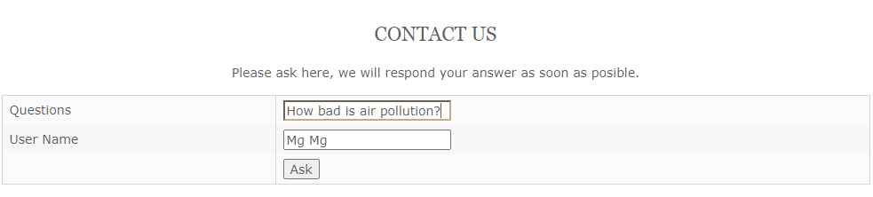

Fig- 2.5

After Testing

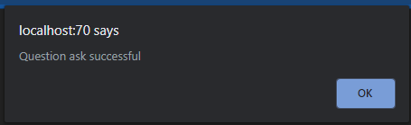

Fig- 2.6

## Testing of FAQ

**Test Case 1**

|  |  |  |
| --- | --- | --- |
| Test objective | Check the FAQ form. |  |
| Test Data | - |  |
| Test Procedure | Click Contact Us button |  |
| Expected Result | Show Contact Us page. |  |
| Actual Result | Fig- 2.8 |  |

Before Testing

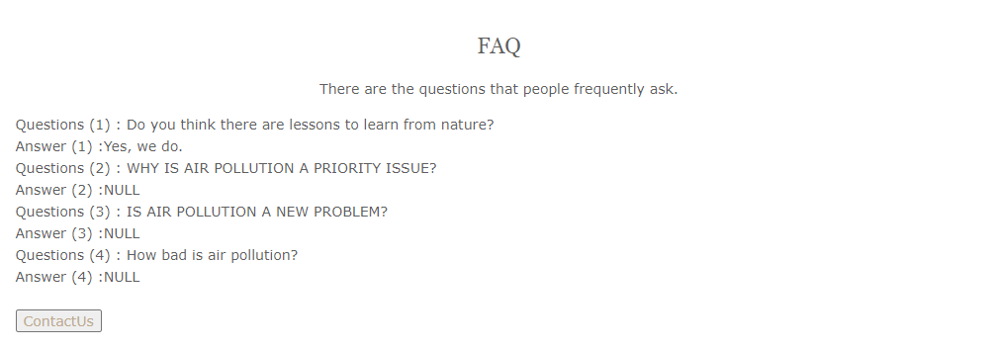

Fig- 2.7

After Testing

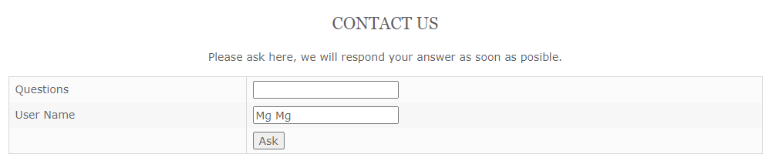

Fig- 2.8

## Testing of View Question

**Test Case 1**

|  |  |  |
| --- | --- | --- |
| Test objective | Check the View Question form. |  |
| Test Data | - |  |
| Test Procedure | Click Answer link in Action column. |  |
| Expected Result | Show Answer page. |  |
| Actual Result | Fig- 2.10 |  |

Before Testing

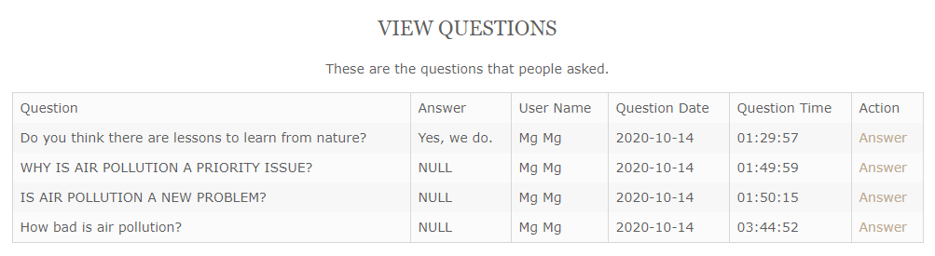

Fig- 2.9

After Testing

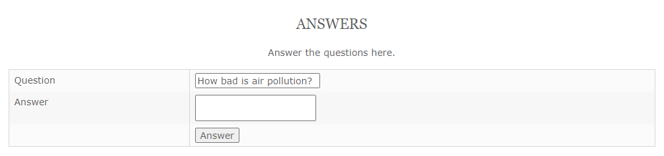

Fig- 2.10

## Testing of Answer

### Test Case 1

|  |  |
| --- | --- |
| Test objective | Check the Answer Page |
| Test Data | Input Answer=” Air pollution is a major environmental health problem affecting everyone. Whether in Manila, Sao Paolo or London, air pollution is a problem from exhaust fumes from cars, domestic combustion or factory smoke. Worldwide it is estimated that 2 million people -- more than half of them in developing countries -- die every year from air pollution. World-wide there are risks to health from exposure to particulate matter (PM) and Ozone (O3) in many cities of developed and developing countries alike..” |
| Test Procedure | Answer the question and Click the Answer button. |
| Expected Result | Show a message box |
| Actual Result | Fig: 2.12 |

Before Testing

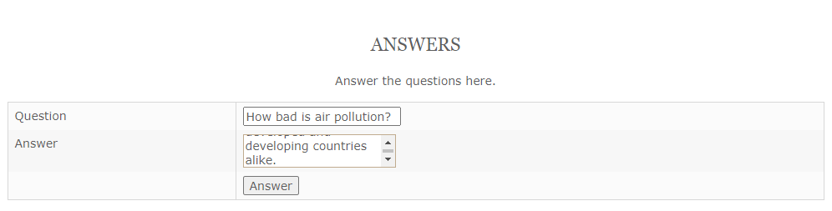

Fig: 2.11

After Testing

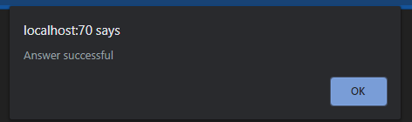

Fig: 2.12

# Task- 4

## Analysis

In task 4, City List and City Register form are included in the task. The scenario want to make the website that can accessible for both phone and tablet and the suitable use of web service and the responsive for every pages.

## Assumptions

For fluid layout connected with all the web pages so all the websites are responsive. Mobile, tablet sizes are all code with CSS in sublime text. Tables are created for City Register and City List in database where the data are meant to store.

## Screen Design

**Location**

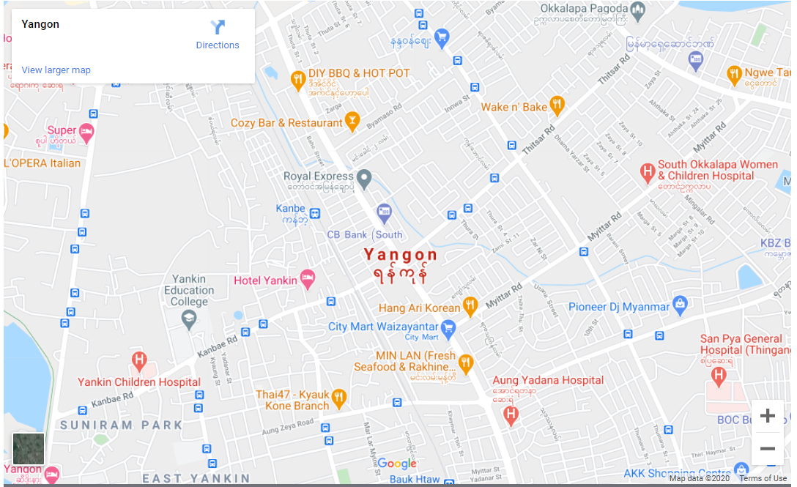

Fig – 3.1

**Mobile Size**

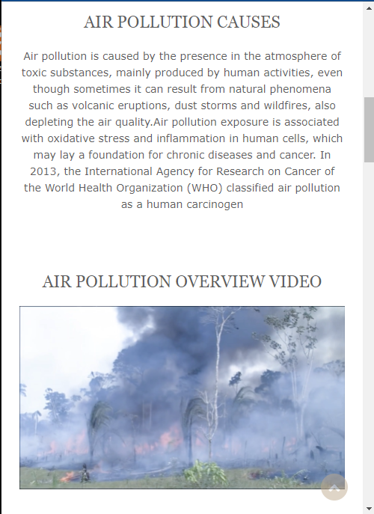

Fig – 3.2

### Tablet Size



Fig – 3.3

### 

**City Register**

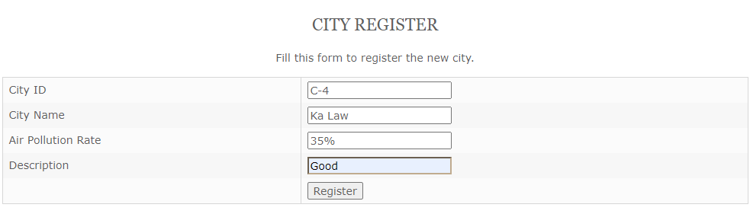

Fig – 3.4

**City List**

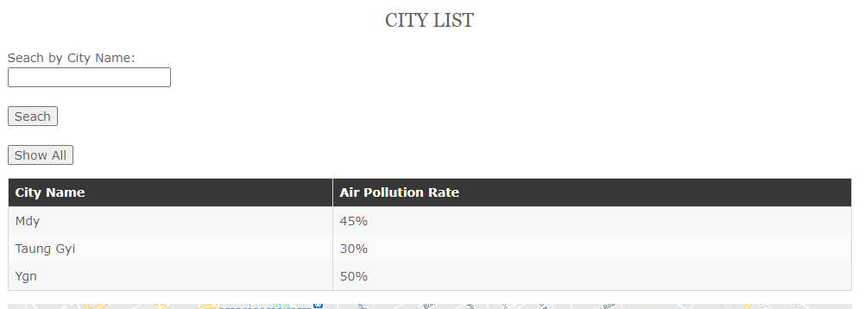

Fig – 3.5

## Coding

<?php

include ('Header2.php');

$connect=mysqli_connect('localhost','root','','Air_Pullution');

if (isset($_POST['btnRegister'])){

$CityID=$_POST['txtCityID'];

$CityName=$_POST['txtCityName'];

$AirPollutionRate=$_POST['txtAirPollutionRate'];

$Description=$_POST['txtDescription'];

$query="INSERT INTO city VALUES('$CityID','$CityName','$AirPollutionRate','$Description')";

$result=mysqli_query($connect,$query);

if ($result) {

echo "<script>alert('Register of City Successful.')</script>";

}

else{

echo "<script>alert('Cannot Register.')</script>";

}

}

?>

<!DOCTYPE html>

<html>

<head>

<title></title>

</head>

<body>

<h2 align="center">City Register</h2>

<p align="center">Fill this form to register the new city.</p>

<form action="city_reg.php" method="POST" enctype="multipart/form-data">

<table>

<tr>

<td>City ID</td>

<td><input type="text" name="txtCityID" required></td>

</tr>

<tr>

<td>City Name</td>

<td><input type="text" name="txtCityName" required></td>

</tr>

<tr>

<td>Air Pollution Rate</td>

<td><input type="text" name="txtAirPollutionRate" required></td>

</tr>

<tr>

<td>Description</td>

<td><input type="text" name="txtDescription" required></td>

</tr>

<tr>

<td></td>

<td><input type="submit" name="btnRegister" value="Register" required></td>

</tr>

</table>

</form>

</body>

</html>

<?php include ('Footer.php');?>

Coding of City Register

<?php

include ('Header.php');

$connection=mysqli_connect('localhost','root','','Air_Pullution');

if (isset($_POST['btnSearch'])) {

$CityName=$_POST['txtCityName'];

$query="SELECT * FROM city WHERE CityName='$CityName'";

$result=mysqli_query($connection,$query);

}

else if (isset($_POST['btnShowAll'])) {

$query="SELECT * FROM city ORDER BY CityName";

$result=mysqli_query($connection,$query);

}

else{

$query="SELECT * FROM city ORDER BY CityName";

$result=mysqli_query($connection,$query);

}

?>

<!DOCTYPE html>

<html>

<head>

<title></title>

</head>

<body>

<h2 align="center">City List</h2>

<form action="Citylist.php" method="POST">

Seach by City Name: <input type="text" name="txtCityName">

<br>

<input type="submit" name="btnSearch" value="Seach">

<br>

<input type="submit" name="btnShowAll" value="Show All">

<table border='1'>

</form>

<?php

$count=mysqli_num_rows($result);

if ($count==0) {

echo "Search Record Not Found";

}

else{

echo "<table border='1'>

<tr>

<th>City Name</th>

<th>Air Pollution Rate</th>

</tr>";

for ($i=0; $i < $count ; $i++) {

$arr=mysqli_fetch_array($result);

echo "<tr>";

echo "<td>".$arr['CityName']."</td>";

echo "<td>".$arr['PollutionRate']."</td>";

echo "</tr>";

}

echo "</table>";

}

?>

</body>

</html>

<div class="mapouter">

<div class="gmap_canvas">

<iframe width="100%" height="600px" id="gmap_canvas" src="https://maps.google.com/maps?q=Yangon&t=&z=13&ie=UTF8&iwloc=&output=embed" frameborder="0" scrolling="no" marginheight="0" marginwidth="0">

</iframe>

<a href="https://123movies-to.org/%22%3E123 movies free online"

</a></div>

<style>.mapouter{position:relative;text-align:right;height:600px%;width:100%;}.gmap_canvas {overflow:hidden;background:none!important;height:600px;width:100%;}

</style>

</div>

<?php include ('Footer.php');?>

Coding of City List

@charset "utf-8";

@import "font-awesome.min.css";

@import "font-awesome-ie7.min.css";

/*

Template Name: Preevent

Author: <a href="https://www.os-templates.com/">OS Templates</a>

Author URI: https://www.os-templates.com/

Licence: Free to use under our free template licence terms

Licence URI: https://www.os-templates.com/template-terms

File: Framework CSS

*/

html{overflow-y:scroll; overflow-x:hidden;}

html, body{margin:0; padding:0; font-size:14px; line-height:1.6em;}

*, *::before, *::after{box-sizing:border-box;}

.bold{font-weight:bold;}

.center{text-align:center;}

.right{text-align:right;}

.uppercase{text-transform:uppercase;}

.capitalise{text-transform:capitalize;}

.hidden{display:none;}

.nospace{margin:0; padding:0; list-style:none;}

.block{display:block;}

.inline *{display:inline-block;}

.inline *:last-child{margin-right:0;}

.pushright1 li{margin-right:20px;}

.pushright li:last-child{margin-right:0;}

.borderedbox{border:1px solid;}

.overlay{position:relative; z-index:1;}

.overlay::after{display:block; position:absolute; top:0; left:0; width:100%; height:100%; content:""; z-index:-1;}

.bgded{background-position:top center; background-repeat:no-repeat; background-size:cover;}

.circle, .btn1, .icon.fa, #backtotop{border-radius:50%; background-clip:padding-box;}

.btn1{display:inline-block; padding:8px 18px 10px; text-transform:uppercase; border:1px solid; border-radius:22px;}

.icon{display:inline-block; width:50px; height:50px; line-height:48px; border:1px solid; text-align:center; font-size:24px;}

.clear, .group{display:block;}

.clear::before, .clear::after, .group::before, .group::after{display:table; content:"";}

.clear, .clear::after, .group, .group::after{clear:both;}

a{outline:none; text-decoration:none;}

.fl_left, .imgl{float:left;}

.fl_right, .imgr{float:right;}

img{width:auto; max-width:100%; height:auto; margin:0; padding:0; border:none; line-height:normal; vertical-align:middle;}

.imgl{margin:0 15px 10px 0; clear:left;}

.imgr{margin:0 0 10px 15px; clear:right;}

/* Fonts

--------------------------------------------------------------------------------------------------------------- */

body, input, textarea, select{font-family:Verdana, Geneva, sans-serif;}

h1, h2, h3, h4, h5, h6, .heading{font-family:Georgia, "Times New Roman", Times, serif;}

/* Forms

--------------------------------------------------------------------------------------------------------------- */

form, fieldset, legend{margin:0; padding:0; border:none;}

legend{display:none;}

label, input, textarea, select, button{display:block; resize:none; outline:none; color:inherit; font-size:inherit; font-family:inherit; vertical-align:middle;}

label{margin-bottom:5px;}

:required, :invalid{outline:none; box-shadow:none;}

/* Generalise

--------------------------------------------------------------------------------------------------------------- */

h1, h2, h3, h4, h5, h6, .heading{margin:0 0 20px 0; font-size:22px; line-height:normal; font-weight:normal; text-transform:uppercase;}

.heading.nospace{margin-bottom:0;}

address{font-style:normal; font-weight:normal;}

hr{display:block; width:100%; height:1px; border:solid; border-width:1px 0 0 0;}

.font-xs{font-size:.8rem;}

.font-x1{font-size:1.2rem;}

.font-x2{font-size:1.8rem;}

.font-x3{font-size:2.8rem;}

.wrapper{display:block; position:relative; width:100%; margin:0; padding:0; text-align:left; word-wrap:break-word;}

/*

The "hoc" class is a generic class used to centre a containing element horizontally

It should be used in conjunction with a second class or ID

*/

.hoc{display:block; margin:0 auto;}

/* HTML 5 Overrides

--------------------------------------------------------------------------------------------------------------- */

address, article, aside, figcaption, figure, footer, header, main, nav, section{display:block; margin:0; padding:0;}

/* Grid

--------------------------------------------------------------------------------------------------------------- */

.one_half, .one_third, .two_third, .one_quarter, .two_quarter, .three_quarter{display:inline-block; float:left; margin:0 0 0 3.06748466257669%; list-style:none;}

.first{margin-left:0; clear:left;}

.one_quarter{width:22.69938650306748%;}

.one_third{width:31.28834355828221%;}

.one_half, .two_quarter{width:48.46625766871166%;}

.two_third{width:65.6441717791411%;}

.three_quarter{width:74.23312883435584%;}

/* Spacing

--------------------------------------------------------------------------------------------------------------- */

.btmspace-10{margin-bottom:10px;}

.btmspace-15{margin-bottom:15px;}

.btmspace-30{margin-bottom:30px;}

.btmspace-50{margin-bottom:50px;}

.btmspace-80{margin-bottom:80px;}

.inspace-5{padding:5px;}

.inspace-10{padding:10px;}

.inspace-15{padding:15px;}

.inspace-30{padding:30px;}

.inspace-50{padding:50px;}

.inspace-80{padding:80px;}

Coding of framework CSS

@charset "utf-8";

/*

Template Name: Preevent

Author: <a href="https://www.os-templates.com/">OS Templates</a>

Author URI: https://www.os-templates.com/

Licence: Free to use under our free template licence terms

Licence URI: https://www.os-templates.com/template-terms

File: Layout CSS

*/

@import url("fontawesome-4.6.3.min.css");

@import url("framework.css");

/* Rows

--------------------------------------------------------------------------------------------------------------- */

.row0, .row0 a{}

.row1, .row1 a{}

.row2, .row2 a{}

.row3, .row3 a{}

.row4, .row4 a{}

.row5, .row5 a{}

/* Header

--------------------------------------------------------------------------------------------------------------- */

#header{}

#header #logo{margin:30px 0 0 0;}

#header #logo h1{margin:0; padding:0; font-size:22px; text-transform:uppercase;}

/* Page Intro

--------------------------------------------------------------------------------------------------------------- */

#pageintro{padding:220px 0; text-align:center;}

#pageintro .heading{display:block; position:relative; margin:0 0 50px 0; padding:0 0 30px 0; font-size:64px;}

#pageintro .heading::after{display:block; position:absolute; bottom:0; left:50%; width:120px; height:2px; margin-left:-60px; content:"";}

#pageintro .txtwrap{display:block; max-width:80%; margin:0 auto;}

#pageintro p{margin:0;}

#pageintro footer{margin-top:80px;}

/* Content Area

--------------------------------------------------------------------------------------------------------------- */

.container{padding:80px 0;}

/* Content */

.container .content{}

.sectiontitle{display:block; margin-bottom:80px;}

.sectiontitle *{margin:0;}

.services{}

.services li{padding:40px 0 0 0; text-align:center;}

.services li:last-child{margin-bottom:0;}/* Used when elements stack in small viewports */

.services li *{}

.services li article{display:block; position:relative; padding:65px 20px 25px 20px; border:1px solid;}

.services li article i{display:inline-block; position:absolute; top:0; left:50%; width:80px; height:80px; line-height:80px; margin:-40px 0 0 -40px; border-radius:50%; font-size:36px; z-index:1;}

.services li article .heading{font-size:1.2rem;}

.services li article footer{margin-top:25px;}

.element article{display:block; max-width:380px;}

.element article .txtwrap{padding:20px 15px;}

.element article .txtwrap *{margin:0 0 15px 0; line-height:5;}

.element article .txtwrap .heading{margin-bottom:5px; font-size:1rem;}

.element article .txtwrap em{display:block; font-size:.8rem; font-style:normal;}

.element article .txtwrap em br{margin:0;}

.element article .txtwrap p{line-height:1.8;}

.element article .txtwrap footer, .element article .txtwrap .btn{margin:0;}

.team.element article{text-align:center; border-bottom:1px solid;}

.team.element article .txtwrap em{text-transform:capitalize;}

.iconlist{margin:30px 0;}

.iconlist li{display:block; margin-bottom:15px; padding:20px;}

.iconlist li:last-child{margin-bottom:0;}

.iconlist li::before, .iconlist li::after{display:table; content:"";}

.iconlist li::after{clear:both;}

.iconlist li > :first-child{float:left; margin-right:5%;}

.iconlist li > :last-child{margin-top:17px;}

.iconlist li *{margin:0;}

.iconlist li .heading{line-height:1; font-size:1.2rem;}

.testimonial{margin:30px 0;}

.testimonial figure{margin-bottom:20px;}

.testimonial figure img{float:left; margin-right:15px;}

.testimonial figure figcaption{float:left; margin:15px 0 0 0;}

.testimonial figure figcaption *{display:block; margin:0; padding:0; line-height:1;}

.testimonial figure figcaption strong{margin-bottom:5px;}

.testimonial figure figcaption br{display:none;}

.testimonial figure figcaption em{font-size:.8rem;}

.testimonial blockquote{display:block; position:relative; width:100%; margin:0; padding:30px 0 0 0; line-height:1.4; z-index:1;}

.testimonial blockquote::before{display:block; position:absolute; top:0; left:0; font-family:"FontAwesome"; font-size:60px; content:"\f10d"; z-index:-1;}

/* Comments */

#comments ul{margin:0 0 40px 0; padding:0; list-style:none;}

#comments li{margin:0 0 10px 0; padding:15px;}

#comments .avatar{float:right; margin:0 0 10px 10px; padding:3px; border:1px solid;}

#comments address{font-weight:bold;}

#comments time{font-size:smaller;}

#comments .comcont{display:block; margin:0; padding:0;}

#comments .comcont p{margin:10px 5px 10px 0; padding:0;}

#comments form{display:block; width:100%;}

#comments input, #comments textarea{width:100%; padding:10px; border:1px solid;}

#comments textarea{overflow:auto;}

#comments div{margin-bottom:15px;}

#comments input[type="submit"], #comments input[type="reset"]{display:inline-block; width:auto; min-width:150px; margin:0; padding:8px 5px; cursor:pointer;}

/* Sidebar */

.container .sidebar{}

.sidebar .sdb_holder{margin-bottom:50px;}

.sidebar .sdb_holder:last-child{margin-bottom:0;}

/* Footer

--------------------------------------------------------------------------------------------------------------- */

#footer{padding:80px 0;}

#footer .heading{margin:0 0 50px 0; padding:0; font-size:1.2rem;}

#footer .sectiontitle .heading{margin-bottom:20px; font-size:2rem;}

#footer .sectiontitle ul{margin-bottom:30px;}

#footer .linklist li{display:block; margin-bottom:15px; padding:0 0 15px 0; border-bottom:1px solid;}

#footer .linklist li:last-child{margin:0; padding:0; border:none;}

#footer .linklist li::before, #footer .linklist li::after{display:table; content:"";}

#footer .linklist li, #footer .linklist li::after{clear:both;}

#footer .contact{}

#footer .contact.linklist li, #footer .contact.linklist li:last-child{position:relative; padding-left:40px;}

#footer .contact li *{margin:0; padding:0; line-height:1.6;}

#footer .contact li i{display:block; position:absolute; top:0; left:0; width:30px; font-size:16px; text-align:center;}

/* Copyright

--------------------------------------------------------------------------------------------------------------- */

#copyright{padding:20px 0;}

#copyright *{margin:0; padding:0;}

/* Transition Fade

--------------------------------------------------------------------------------------------------------------- */

*, *::before, *::after{transition:all .3s ease-in-out;}

#mainav form *{transition:none !important;}

/* ------------------------------------------------------------------------------------------------------------ */

/* ------------------------------------------------------------------------------------------------------------ */

/* ------------------------------------------------------------------------------------------------------------ */

/* ------------------------------------------------------------------------------------------------------------ */

/* ------------------------------------------------------------------------------------------------------------ */

/* Navigation

--------------------------------------------------------------------------------------------------------------- */

nav ul, nav ol{margin:0; padding:0; list-style:none;}

#mainav, #breadcrumb, .sidebar nav{line-height:normal;}

#mainav .drop::after, #mainav li li .drop::after, #breadcrumb li a::after, .sidebar nav a::after{position:absolute; font-family:"FontAwesome"; font-size:10px; line-height:10px;}

/* Top Navigation */

#mainav{}

#mainav ul{text-transform:uppercase;}

#mainav ul ul{z-index:9999; position:absolute; width:180px; text-transform:none;}

#mainav ul ul ul{left:180px; top:0;}

#mainav li{display:inline-block; position:relative; margin:0 15px 0 0; padding:0;}

#mainav li:last-child{margin-right:0;}

#mainav li li{width:100%; margin:0;}

#mainav li a{display:block; padding:30px 0;}

#mainav li li a{border:solid; border-width:0 0 1px 0;}

#mainav .drop{padding-left:15px;}

#mainav li li a, #mainav li li .drop{display:block; margin:0; padding:10px 15px;}

#mainav .drop::after, #mainav li li .drop::after{content:"\f0d7";}

#mainav .drop::after{top:35px; left:5px;}

#mainav li li .drop::after{top:15px; left:5px;}

#mainav ul ul{visibility:hidden; opacity:0;}

#mainav ul li:hover > ul{visibility:visible; opacity:1;}

#mainav form{display:none; margin:0; padding:0;}

#mainav form select, #mainav form select option{display:block; cursor:pointer; outline:none;}

#mainav form select{width:100%; padding:5px; border:1px solid;}

#mainav form select option{margin:5px; padding:0; border:none;}

/* Breadcrumb */

#breadcrumb{padding:120px 0 30px;}

#breadcrumb ul{margin:0 0 30px 0; padding:0 0 8px 0; list-style:none; text-transform:uppercase; border-bottom:1px solid;}

#breadcrumb li{display:inline-block; margin:0 6px 0 0; padding:0;}

#breadcrumb li a{display:block; position:relative; margin:0; padding:0 12px 0 0; font-size:12px;}

#breadcrumb li a::after{top:3px; right:0; content:"\f101";}

#breadcrumb li:last-child a{margin:0; padding:0;}

#breadcrumb li:last-child a::after{display:none;}

#breadcrumb .heading{margin:0; font-size:2rem;}

/* Sidebar Navigation */

.sidebar nav{display:block; width:100%;}

.sidebar nav li{margin:0 0 3px 0; padding:0;}

.sidebar nav a{display:block; position:relative; margin:0; padding:5px 10px 5px 15px; text-decoration:none; border:solid; border-width:0 0 1px 0;}

.sidebar nav a::after{top:9px; left:5px; content:"\f101";}

.sidebar nav ul ul a{padding-left:35px;}

.sidebar nav ul ul a::after{left:25px;}

.sidebar nav ul ul ul a{padding-left:55px;}

.sidebar nav ul ul ul a::after{left:45px;}

/* Pagination */

.pagination{display:block; width:100%; text-align:center; clear:both;}

.pagination li{display:inline-block; margin:0 2px 0 0;}

.pagination li:last-child{margin-right:0;}

.pagination a, .pagination strong{display:block; padding:8px 11px; border:1px solid; background-clip:padding-box; font-weight:normal;}

/* Back to Top */

#backtotop{z-index:999; display:inline-block; position:fixed; visibility:hidden; bottom:20px; right:20px; width:36px; height:36px; line-height:36px; font-size:16px; text-align:center; opacity:.2;}

#backtotop i{display:block; width:100%; height:100%; line-height:inherit;}

#backtotop.visible{visibility:visible; opacity:.5;}

#backtotop:hover{opacity:1;}

/* Tables

--------------------------------------------------------------------------------------------------------------- */

table, th, td{border:1px solid; border-collapse:collapse; vertical-align:top;}

table, th{table-layout:auto;}

table{width:100%; margin-bottom:15px;}

th, td{padding:5px 8px;}

td{border-width:0 1px;}

/* Gallery

--------------------------------------------------------------------------------------------------------------- */

#gallery{display:block; width:100%; margin-bottom:50px;}

#gallery figure figcaption{display:block; width:100%; clear:both;}

#gallery li{margin-bottom:30px;}

/* ------------------------------------------------------------------------------------------------------------ */

/* ------------------------------------------------------------------------------------------------------------ */

/* ------------------------------------------------------------------------------------------------------------ */

/* ------------------------------------------------------------------------------------------------------------ */

/* ------------------------------------------------------------------------------------------------------------ */

/* Colours

--------------------------------------------------------------------------------------------------------------- */

body{color:#D3D3D3; background-color:#212121;}

a{color:#C0AB8F;}

a:active, a:focus{background:transparent;}/* IE10 + 11 Bugfix - prevents grey background */

hr, .borderedbox{border-color:#D7D7D7;}

label span{color:#FF0000; background-color:inherit;}

input:focus, textarea:focus, *:required:focus{border-color:#C0AB8F;}

.overlay{color:#FFFFFF; background-color:inherit;}

.overlay::after{background-color:rgba(0,0,0,.3);}

.overlay.light::after{background-color:rgba(255,255,255,.55);}

.btn1, .btn.inverse:hover{color:#FFFFFF; background-color:#C0AB8F; border-color:#C0AB8F;}

.btn1:hover, .btn.inverse{color:inherit; background-color:transparent; border-color:inherit;}

/* Rows */

.row0, .row0 a{}

.row1{color:#FFFFFF; background-color:rgba(0,0,0,.3);}

.row2{color:#5F5F5F; background-color:#F7F7F7;}

.row3{color:#5F5F5F; background-color:#FFFFFF;}

.row4{color:#D3D3D3; background-color:#2D2D2D;}

.row5, .row5 a{color:#D3D3D3; background-color:#212121;}

/* Top Bar */

#topbar, #topbar ul li{border-color:rgba(255,255,255,.3);}

#topbar > div:last-of-type li:first-child a{color:#C0AB8F;}

/* Header */

#header #logo a{color:inherit;}

/* Page Intro */

#pageintro .heading::after{background-color:#C0AB8F;}

/* Content Area */

.services li article{border-color:#D7D7D7;}

.services li article i{color:#FFFFFF; background:#D7D7D7;}

.services li article:hover i{background:#C0AB8F;}

.services li article:hover, .services li article:hover i{box-shadow:2px 2px rgba(0,0,0,.2);}

.element article .txtwrap{color:#5F5F5F; background-color:#FFFFFF;}

.team.element article{border-color:transparent;}

.team.element article:hover{border-color:#C0AB8F;}

.team.element article .txtwrap{color:inherit; background-color:#F7F7F7;}

.iconlist li{background-color:rgba(255,255,255,.1);}

.iconlist li a{color:inherit;}

.iconlist li:hover{color:#5F5F5F; background-color:#FFFFFF;}

.iconlist li:hover a i{color:#FFFFFF; background-color:#C0AB8F;}

.testimonial blockquote::before{color:rgba(255,255,255,.1);}

/* Footer */

#footer .heading{color:#FFFFFF;}

#footer hr, #footer .borderedbox, #footer .linklist li{border-color:rgba(255,255,255,.2);}

/* Navigation */

#mainav li a{color:inherit;}

#mainav .active a, #mainav a:hover, #mainav li:hover > a{color:#C0AB8F; background-color:inherit;}

#mainav li li a, #mainav .active li a{color:#FFFFFF; background-color:rgba(0,0,0,.6); border-color:rgba(0,0,0,.6);}

#mainav li li:hover > a, #mainav .active .active > a{color:#FFFFFF; background-color:#C0AB8F;}

#mainav form select{color:#FFFFFF; background-color:#000000; border-color:rgba(255,255,255,.3);}

#breadcrumb ul{border-color:rgba(255,255,255,.2);}

#breadcrumb a{color:inherit; background-color:inherit;}

#breadcrumb li:last-child a{color:#C0AB8F;}

.container .sidebar nav a{color:inherit; border-color:#D7D7D7;}

.container .sidebar nav a:hover{color:#C0AB8F;}

.pagination a, .pagination strong{border-color:#D7D7D7;}

.pagination .current *{color:#FFFFFF; background-color:#C0AB8F;}

#backtotop{color:#FFFFFF; background-color:#C0AB8F;}

/* Tables + Comments */

table, th, td, #comments .avatar, #comments input, #comments textarea{border-color:#D7D7D7;}

#comments input:focus, #comments textarea:focus, #comments *:required:focus{border-color:#C0AB8F;}

th{color:#FFFFFF; background-color:#373737;}

tr, #comments li, #comments input[type="submit"], #comments input[type="reset"]{color:inherit; background-color:#FBFBFB;}

tr:nth-child(even), #comments li:nth-child(even){color:inherit; background-color:#F7F7F7;}

table a, #comments a{background-color:inherit;}

/* ------------------------------------------------------------------------------------------------------------ */

/* ------------------------------------------------------------------------------------------------------------ */

/* ------------------------------------------------------------------------------------------------------------ */

/* ------------------------------------------------------------------------------------------------------------ */

/* ------------------------------------------------------------------------------------------------------------ */

/* Media Queries

--------------------------------------------------------------------------------------------------------------- */

@-ms-viewport{width:device-width;}

/* Max Wrapper Width - Laptop, Desktop etc.

--------------------------------------------------------------------------------------------------------------- */

@media screen and (min-width:978px){

.hoc{max-width:978px;}

}

/* Mobile Devices

--------------------------------------------------------------------------------------------------------------- */

@media screen and (max-width:900px){

.hoc{max-width:90%;}

#header{padding:30px 0;}

#header #logo{margin-top:3px;}

#mainav{}

#mainav ul{display:none;}

#mainav form{display:block;}

#breadcrumb{}

.container{}

#comments input[type="reset"]{margin-top:10px;}

.pagination li{display:inline-block; margin:0 5px 5px 0;}

#footer{}

#copyright{}

#copyright p:first-of-type{margin-bottom:10px;}

}

@media screen and (min-width:750px) and (max-width:900px){

.iconlist li > :last-child{margin-top:8px;}

}

@media screen and (max-width:750px){

.imgl, .imgr{display:inline-block; float:none; margin:0 0 10px 0;}

.fl_left, .fl_right{display:block; float:none;}

.group .group > *:last-child, .clear .clear > *:last-child, .clear .group > *:last-child, .group .clear > *:last-child{margin-bottom:0;}

/* Experimental - Needs more testing in different situations, stops double margin when stacking */

.one_half, .one_third, .two_third, .one_quarter, .two_quarter, .three_quarter{display:block; float:none; width:auto; margin:0 0 30px 0; padding:0;}

#header{text-align:center;}

#header #logo{margin:0 0 15px 0;}

#pageintro{padding:120px 0;}

#pageintro .heading{font-size:3rem;}

#pageintro .txtwrap{max-width:none;}

#footer{padding-bottom:50px;}/* Not neccessary - just looks better */

}

@media screen and (max-width:450px){

.iconlist li > :last-child{margin-top:5px;}

}

/* Other

--------------------------------------------------------------------------------------------------------------- */

@media screen and (max-width:650px){

.scrollable{display:block; width:100%; margin:0 0 30px 0; padding:0 0 15px 0; overflow:auto; overflow-x:scroll;}

.scrollable table{margin:0; padding:0; white-space:nowrap;}

.inline li{display:block; margin-bottom:10px;}

.pushright1 li{margin-right:0;}

.font-x2{font-size:1.4rem;}

.font-x3{font-size:1.6rem;}

#pageintro .heading{font-size:2rem;}

}

Coding of layout CSS

(w3schools, 2019)

## Testing of City Register

### Test Case 1

|  |  |
| --- | --- |
| Test objective | Checking the City Register |
| Test Data | CityID=”C-4”City Name=”Ka Law”, , Air Pollution Rate=35%”, Description=”Good” |
| Test Procedure | Enter all data and Click the Register Button |
| Expected Result | Show a message box |
| Actual Result | Fig: 3.7 |

Before Testing



Fig – 3.6

After Testing

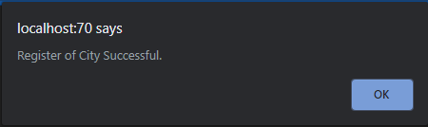

Fig-3.7

## Testing of City List

### Test Case 1

|  |  |
| --- | --- |
| Test objective | Checking the City List |
| Test Data | - |
| Test Procedure | Type the city name and Click Search Button. |
| Expected Result | Show a message box |
| Actual Result | Fig: 3.9 |

Before Testing

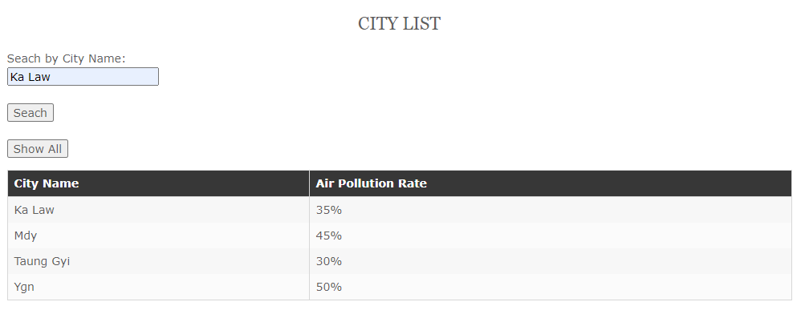

Fig – 3.8

After Testing

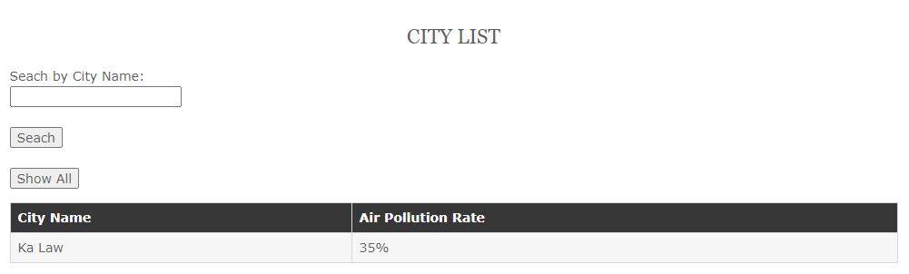

Fig-3.9

# Task – 5

## Analysis

In task 5, View history page will be created for the user’s history record where users can check the record what did they do.

## Assumptions

A history table is created in database to store the record history of a User well. To work will the insert history code for every page where user goes.

## Screen Design

**View History**

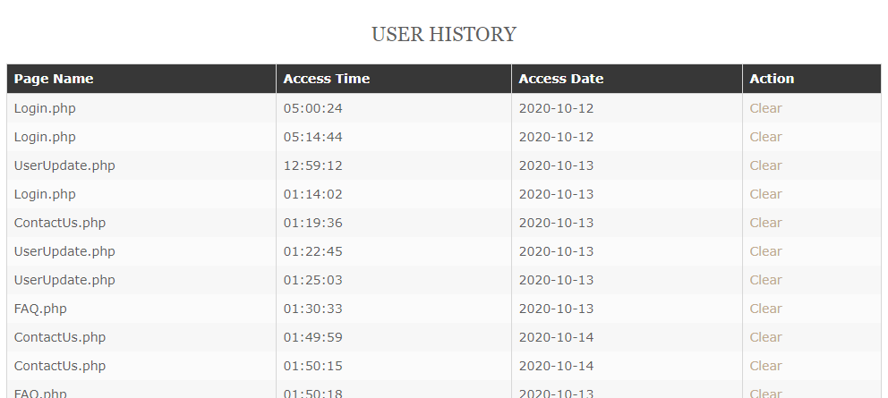

Fig: 4.1 View history

## Coding

<?php

include ('Header.php');

$connect=mysqli_connect('localhost','root','','Air_Pullution');

if (isset($_SESSION['UserID'])) {

$UserID=$_SESSION['UserID'];

$query="SELECT * FROM history WHERE UserID='$UserID'";

$result=mysqli_query($connect,$query);

$count=mysqli_num_rows($result);

}

else{

echo "<script>alert('Please Login First.')</script>";

echo "<script>window.location='login.php';</script>";

}

if (isset($_REQUEST['HID'])) {

$HistoryID=$_REQUEST['HID'];

$query1="DELETE FROM history WHERE HistoryID='$HistoryID'";

$result1=mysqli_query($connect,$query1);

if ($result1) {

echo "<script>window.location='ViewHistory.php';</script>";

}

}

if (isset($_POST['btnClearAll'])) {

$query2="DELETE FROM history WHERE UserID='$UserID'";

$result2=mysqli_query($connect,$query2);

if ($result2) {

echo "<script>window.location='viewhistory.php';</script>";

}

}

?>

<!DOCTYPE html>

<html>

<head>

<title></title>

</head>

<h2 align="center">User History</h2>

<body>

<?php

if ($count>0) {

echo "<form action='viewhistory.php' method='POST'>";

echo "<table border='1'>

<tr>

<th>Page Name</th>

<th>Access Time</th>

<th>Access Date</th>

<th>Action</th>

</tr>";

for ($i=0; $i < $count ; $i++) {

$arr=mysqli_fetch_array($result);

echo "<tr>";

echo "<td>".$arr['PageName']."</td>";

echo "<td>".$arr['AccessTime']."</td>";

echo "<td>".$arr['AccessDate']."</td>";

echo "<td><a href='viewhistory.php?HID=".$arr['HistoryID']."'>Clear</a></td>";

echo "</tr>";

}

echo "<tr>

<td colspan='4' align='center'><input type='submit' name='btnClearAll' value='Clear All History'></td>

</tr>";

echo "</table>";

echo "</form>";

}

else{

echo "Not User History";

}

?>

</body>

</html>

<?php include ('Footer.php');?>

Coding of View History

## Testing of View History

### Test Case 1

|  |  |
| --- | --- |
| Test objective | Checking the user history |
| Test Data | - |
| Test Procedure | Choose one page and Click the Clear Link in action. |
| Expected Result | To delete the record of Contact Us page |
| Actual Result | Fig-4.3 |

Before Testing

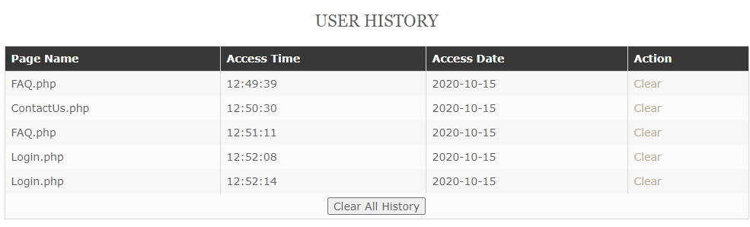

Fig-4.2

After Testing

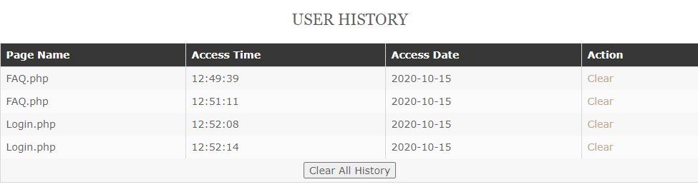

Fig:4.3

### Test Case 2

|  |  |
| --- | --- |
| Test objective | Checking the User history |
| Test Data | - |
| Test Procedure | Click the Clear All History button. |
| Expected Result | To delete all the records in the history. |
| Actual Result | Fig: 4.5 |

Before Testing



Fig-4.4

After Testing



Fig-4.5

# Task – 6

## Evaluations

## In this assignment, my job as a Web developer who creates the database, web pages and forms for both user and staff. Goal is to create a fluid layout with eye-catching website that can use on both mobiles and tablets.

## The website is divided into two parts one is for User and one is for Staff. In users’ part there are pages called Register, Login, User Update, View Product, Get Gift, City List, FAQ, Contact Us and History Records. Each page is designed with PHP, html and CSS. In staffs’ part there are pages called Staff Register, Staff Login, Product update, City Register, Answer. For the whole website, I use a template that will fit with the needs in this assignment. After adding that temple I faced with many errors with PHP codes but I tried to fix them as possible as I can do.

## Because of this assignment, I learn more about PHP, CSS and database with their errors. And also error solving skills are improved. I research about Air Pollution on online and rewrite about it in home page. I also got knowledge about Air Pollution. I also research about more website about Air Pollution. By adding more pages or CSS codes the website could be more colorful. This assignment helps me a lot to solve errors well for the codes and database. By doing these tasks I know very well about the PHP, html and CSS and also know about the job of a web developer is not very easy.

# References

*www.hu.mtu.edu*. (2012). Retrieved September 10, 2020, from http://www.hu.mtu.edu/~emnorton/emnorton/portfolio/personal_portfolio/Assets/webdesignreflection.pdf

CSS, F. (2020). *Free CSS*. Retrieved September 14, 2020, from https://www.free-css.com/free-css-templates/page187/wildflat

University of Cumbria. (2016). *ReflectiveModelRolfe*. Retrieved 10 7, 2020, from https://my.cumbria.ac.uk/media/MyCumbria/Documents/ReflectiveModelRolfe.pdf

w3schools. (2019). *w3schools*. Retrieved September 22, 2020, from https://www.w3schools.com/

## Candidate Checklist

Please use the following checklist to ensure that your work is ready for submission.



Have you read the NCC Education documents 'What is Academic Misconduct? Guidance for Candidates' and 'Avoiding Plagiarism and Collusion: Guidance for Candidates' and ensured that you have acknowledge all the sources that you have used in your work?



Have you completed the 'Statement and Confirmation of Own Work' form and attached it to your assignment? **You must do this**.

Have you ensured that your work has not gone over or under the recommended word count by more than 10%?



Have you ensured that your work does not contain viruses and can be run directly?

